5/5/17

Snuggets for Seattle and King County Ready

# *Notes for translators: Thank you for your help on this project!

# 1) IMPORTANT! When you are translating this document please maintain the formatting. I will be weaving html format back into the translations.

* If something is **bolded**, keep it **bolded** when translated.
* If something is hyperlinked, please highlight in blue (no need to hyperlink it again, but I do need to know where to put links back in)
* If there is numbering or bullets please retain those in the translation

2) You do not need to translate the left-hand column of the tables. It is only for organization purposes. (For example, on the next page it says intensity 5 on the left. You can leave that as-is and only translate the text to the right that starts with “There is a…”)

3) You do not need to translate text on images.

If you have any questions during translation feel free to email or call Carson at 206-832-7590 or carson@hazardready.org.

# Dhul gariirka

## Oo noloshaada ah: Nisqually 6.8

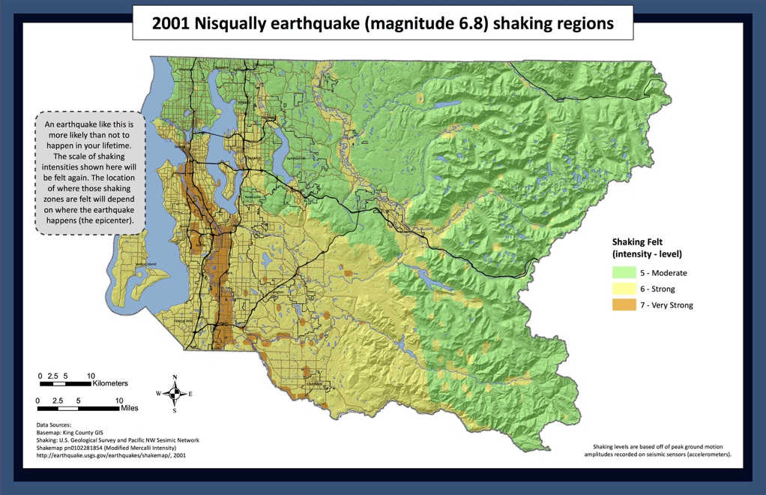

|  |  |
| --- | --- |
| Intensity 5 | Waxaa jiro **FURSAD SAREYSO** (84%) ee baaxada 6.5+ dhulgariir qotodheer oo dhufanayo 50 sanno ee xigo. Waxay dareemeysaa si lamid ah M6.8 ee Dhulgariirka Nisqually ee 2001. Gariirka dhaxedhaxaadka waxaa dareemaya ku dhawaad qof walboo halkaan joogo. **Albaabada wuu lulmayaa, sawirada darbiyada way shanqarayaan, iyo sheeyada yaryar way dhici karaan. Waxyeelada way yaraaneysaa**. [(qariirada)](https://hazardready.org/seattle/static/img/data/Earthquake_Nisqually.jpg) |
| Intensity 6 | Waxaa jiro **FURSAD SAREYSO** (84%) ee baaxada 6.5+ dhulgariir qotodheer oo dhufanayo 50 sanno ee xigo. Waxay dareemeysaa si lamid ah M6.8 ee Dhulgariirka Nisqually ee 2001. **Gariir xoogan wuu ku adkeynayaa inuu halkaan ku lugeeyo. Buuggaagta, galaasyada, iyo sheeyada way ka dhacayaan iska faalooyinka. Albaabada armaajada iyo qaanadaha way furmayaan**. Qaar ka mid ah shooladaha iyo si liito ugu dhisan dhismooyinka way waxyeeloobayaan.[(qariirada)](https://hazardready.org/seattle/static/img/data/Earthquake_Nisqually.jpg) |
| Intensity 7 | Waxaa jiro **FURSAD SAREYSO** (84%) ee baaxada 6.5+ dhulgariir qotodheer oo dhufanayo 50 sanno ee xigo. Waxay dareemeysaa si lamid ah M6.8 ee Dhulgariirka Nisqually ee 2001. **Gariir aad u xoogan ayaa ku adkeynayo in halkaan la taagnaado. Alaabta guriga way dhaqaaqeysaa iyo sheeyo badan waxay ka soo dhacayaan iska faalooyinka.** Waxyeelada muhiim ah oo si liidato ugu dhisan qaabdhismeedyada oo wax yar dhexdhaxaadinayo qaabdhismeedyo caadi ah. [(qariirada)](https://hazardready.org/seattle/static/img/data/Earthquake_Nisqually.jpg) |

## Dhulgariirka Ruxuda Cascadia

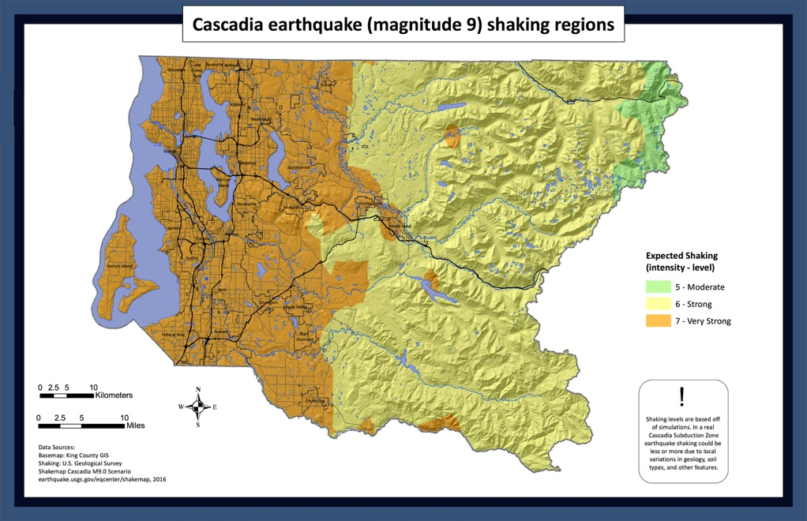

|  |  |
| --- | --- |
| Intensity 5 | Waxaa jiro **FURSAD DHEXDHAXAAD** (10-30%) ee baaxada 8+ dhulgariirka Cascadia oo dhufanayo Wuqooyiga galbeed ee 50 sanno ee xiggo. **Marka ay dhacdo, waxaad dareemeysaa gariir dhexdhaxaad ah ee ku adkeysto daqiiqado halkaan. Sheeyada aan badbaadada aheyn way ka dhacayaan iska faalooyinka. Albaabada armaajada way lulmayaan oo furmayaan oo xirmayaan**. Awooda iyo biyaha way dan sanaan karaan maalmo illaa isbuucyo. [(qariirada)](https://hazardready.org/seattle/static/img/data/Earthquake_Cascadia.jpg) |
| Intensity 6 | Waxaa jiro **FURSAD DHEXDHAXAAD** (10-30%) ee baaxada 8+ dhulgariirka Cascadia oo dhufanayo Wuqooyiga galbeed ee 50 sanno ee xiggo. **Marka ay dhacdo, waxaad dareemeysaa gariir xoogan ah halhaan ee ku adkeysto daqiiqado. Way adkaaneysaa in la socdo. Dhismooyinka Bulkeetiga oo Culu way waxyeeloobayaan iyo dadka way dhaawacmayaan**. Awooda iyo biyaha way damayaan maalmo illaa isbuucyo. [(qariirada)](https://hazardready.org/seattle/static/img/data/Earthquake_Cascadia.jpg) |
| Intensity 7 | Waxaa jiro **FURSAD DHEXDHAXAAD** (10-30%) ee baaxada 8+ dhulgariirka Cascadia oo dhufanayo Wuqooyiga galbeed ee 50 sanno ee xiggo. **Marka ay dhacdo, waxaad dareemeysaa gariir aad u xoogan ee ku adkeysto daqiiqado halkaan. Taagnaashada way adkaaneysaa iyo wax badan ayaa dhaawacmayo. Bulkeetiyada iyo galaasyada burbursan waxay aftiiminayaan wadooyinka**. Awooda iyo biyaha way damayaan maalmo illaa isbuucyo. [(qariirada)](https://hazardready.org/seattle/static/img/data/Earthquake_Cascadia.jpg) |

## Xaalada ugu xun: Qaladka Seattle 7.2 matalaada

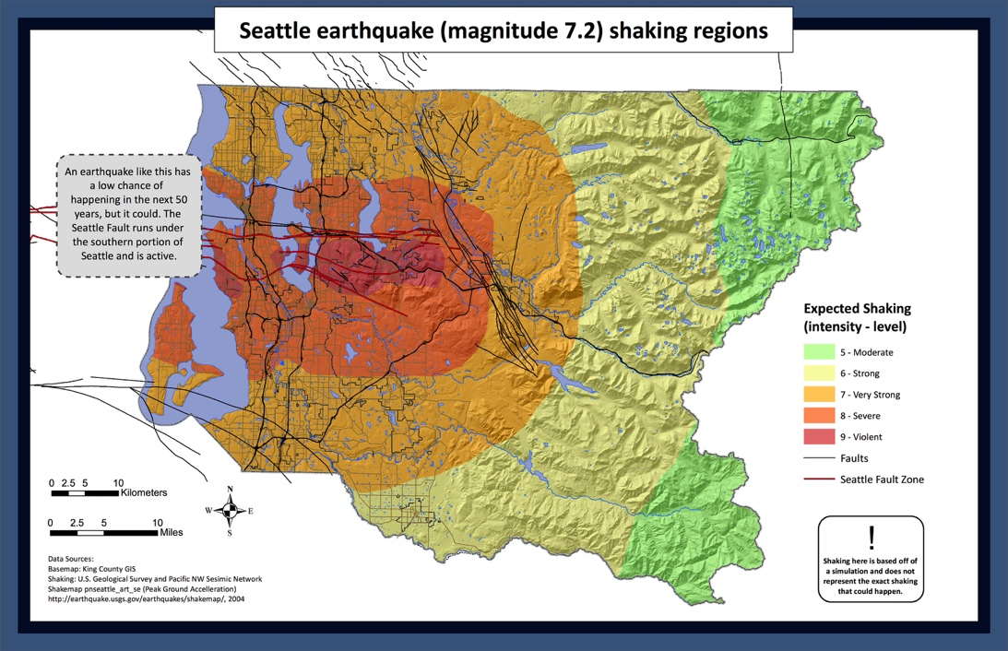

|  |  |
| --- | --- |
| Intensity 5 | **FURSAD HOOSE** (5%) ee ka jirto baaxada 7+ dhulgariirka Qaladka Seattle ee 50 sanno ee xiggo, laakin haddii ay sameyso waxyeelo ayay noqoneysaa. **Gariirka dhaxedhaxaadka waxaa dareemaya ku dhawaad qof walboo joogo. Albaabada wuu lulmayaa, sawirada darbiyada way shanqarayaan, iyo sheeyada yaryar way dhici karaan. Waxyeelada way yaraaneysaa**. [(qariirada)](https://hazardready.org/seattle/static/img/data/Earthquake_Seattle.jpg) |
| Intensity 6 | **FURSAD HOOSE** (5%) ee ka jirto baaxada 7+ dhulgariirka Qaladka Seattle ee 50 sanno ee xiggo, laakin haddii ay sameyso waxyeelo ayay noqoneysaa. Gariir xoogan wuu ku adkeynayaa inuu ku lugeeyo. **Buuggaagta, galaasyada, iyo sheeyada way ka dhacayaan iska faalooyinka. Qaar ka mid ah shooladaha iyo si liito ugu dhisan dhismooyinka way waxyeeloobayaan.** [(qariirada)](https://hazardready.org/seattle/static/img/data/Earthquake_Seattle.jpg) |
| Intensity 7 | **FURSAD HOOSE** (5%) ee ka jirto baaxada 7+ dhulgariirka Qaladka Seattle ee 50 sanno ee xiggo, laakin haddii ay sameyso waxyeelo ayay noqoneysaa. **Gariir aad u xoogan ayaa adkeyneyso in la taagnaado. Alaabta guriga way dhaqaaqeysaa iyo sheeyo ayaa dhacayo**. Waxyeelada waxay muhiim u noqoneysaa dhismooyinka sida liidato loo dhisay iyo dhexdhaxaadka dhismooyinka caadiga ah. [(qariirada)](https://hazardready.org/seattle/static/img/data/Earthquake_Seattle.jpg)  [lick on this image to be taken to a video of a simulated magnitude 7 earthquake and the impacts along the Alaskan Way Viaduct](https://www.youtube.com/watch?v=hos_uIKwC-c) |
| Intensity 8 | **FURSAD HOOSE** (5%) ee ka jirto baaxada 7+ dhulgariirka Qaladka Seattle ee 50 sanno ee xiggo, laakin haddii ay sameyso waxyeelo ayay noqoneysaa. **Gariir daran ayaa ku adkeynayo in la taagnaado ama la kaxeeyo. Alaabaha guriga culus waa la afgambinayaa. Qeybaha dhismooyinka** [**URM**](http://www.seattle.gov/dpd/codesrules/changestocode/unreinforcedmasonrybuildings/whatwhy/) **wuu burburayaa iyo guryaha naqshada alwaaxa waxay isku badelayaan aasaasyada.**[(qariirada)](https://hazardready.org/seattle/static/img/data/Earthquake_Seattle.jpg)  [lick on this image to be taken to a video of a simulated magnitude 7 earthquake and the impacts along the Alaskan Way Viaduct](https://www.youtube.com/watch?v=hos_uIKwC-c) |
| Intensity 9 | **FURSAD HOOSE** (5%) ee ka jirto baaxada 7+ dhulgariirka Qaladka Seattle ee 50 sanno ee xiggo, laakin haddii ay sameyso waxyeelo ayay noqoneysaa. **Gariirka xiigan wuxuu ku sababayaa faafida naxdinta iyo dilaacyada dhulka way aasaasmeysaa. Dhulka buuraha waxaa lagu kicinayaa dalcadaha dagaandaga iyo godka waxay ka dhaceysaa ciidaha qoyan.** [(qariirada)](https://hazardready.org/seattle/static/img/data/Earthquake_Seattle.jpg)  [lick on this image to be taken to a video of a simulated magnitude 7 earthquake and the impacts along the Alaskan Way Viaduct](https://www.youtube.com/watch?v=hos_uIKwC-c) |

## Qaladka Tusunaamiga Seattle

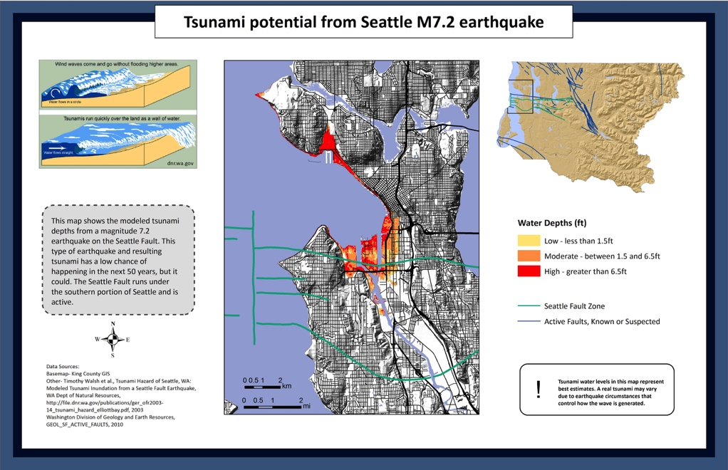

|  |  |
| --- | --- |
| 1, High (depth>=6.5feet) | Waxaad joogtaa **aaga tusanaamiga halista SEREYSO.** Heerarka biyaha waxay ka sara kacayaan madaxaaga daqiiqado illaa tobannaadyo daqiiqado ee xigo dhulgariirka. Markii gariirka joogsado KA GUUR ISLA MARKIIBA dhul sareeyo. [(qariirada)](https://hazardready.org/seattle/static/img/data/Earthquake_Tsunami.jpg) |
| 2, Mod (1/5 < depth < 6.5 feet) | Waxaad joogtaa **aaga tusanaamiga halista SEREYSO.** Heerarka biyaha waxay ku gaarayaan inta u dhaxeyso jilbahaaga iyo madaxaaga daqiiqa illaa tobanaadyo daqiiqad ee xiggaa dhul gariirka. Markii gariirka joogsado KA GUUR ISLA MARKIIBA dhul sareeyo. [(qariirada)](https://hazardready.org/seattle/static/img/data/Earthquake_Tsunami.jpg) |
| 3, Low (depth < 1.5 feet) | Waxaad joogtaa **aaga tusanaamiga halista SEREYSO.** Heerarka biyaha waxay gaarayaan illaa ilbahaaga ee degdega hadeer ee ku filan inuu kugu dhufto. Waxaad haysataa daqiiqado illaa toban daqiiqado ee looga GUURAYO dhulal sareeyo. [(qariirada)](https://hazardready.org/seattle/static/img/data/Earthquake_Tsunami.jpg) |
| 4, Tsunami Study Area (no 5, tsunami) | **Waxaad banaanka ka jirtaa aaga tusunaamiga halista ah ee la calaameeyay**, laakin hirarka tusanaamiga way isbedeli kartaa. Miyaad ku nooqshahay ama ka shaqeysaa aaga buur hoose (ee gudaha 30fiit ee heerka biyaha) u dhow badda? Haddii ay sidaas tahay, KA GUUR ISLA MARKIIBA dhul sareeyo kadib dhul weyn. [(qariirada)](https://hazardready.org/seattle/static/img/data/Earthquake_Tsunami.jpg) |
| 5, Quarter mile coastline buffer | **Waxaad ku jirtaa gudaha rubac mayl ee badda**. Haddii joogtid meel buur hoose (within 30fiit ee heerka badda) waxaad halis ugu jiri kartaa tusanaami ee xigga dhul gariirka u dhow. Raadi dhul sareeyo isla markiiba. [(qariirada)](https://hazardready.org/seattle/static/img/data/Earthquake_Tsunami.jpg) |
| 7, Ocean | Haddii aad doon saarantahay inta lagu jiro dhul gariirka waxaad la kulmi kartaa hirarka dhaqaaqa tusunaamiga oo xoogan oo kugu soo socdo. T illaa iyada. [(qariirada)](https://hazardready.org/seattle/static/img/data/Earthquake_Tsunami.jpg) |

## Godadka

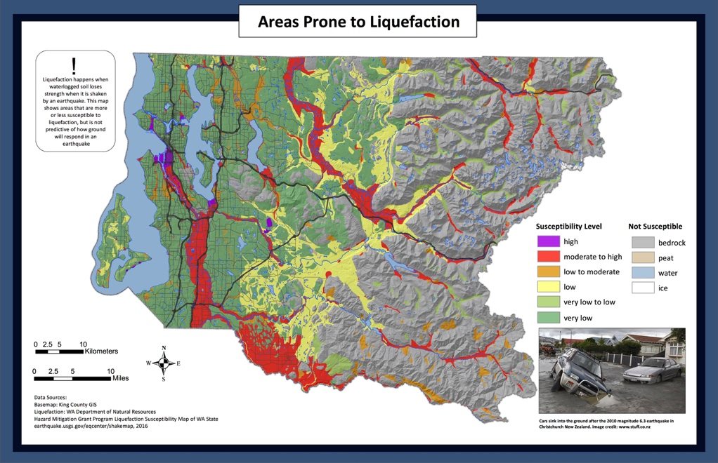

|  |  |
| --- | --- |
| High | **Imaan karo: SAREEYO**  Ciida rokmeyso waxay noqoneysaa mid aan aad u xasilooneyn oo waxay u dhaqmeysaa sida ciid degdega ah. Biyaha ciida ka buuxo kor ayaa soo aadi kartaa oo dhinaca dilaacyada wadooyinka. [(qariirada)](https://hazardready.org/seattle/static/img/data/Earthquake_liquefaction.jpg) |
| Moderate - High | **Imaan karo: DHEXDHAXAAD - SAREEYO**  Ciida gariirmeyso waxay noqoneysaa mid aan xasilooneyn. Tani waxay yareyneysaa kartida ciida looga baxayo ee guryahaa haysto, baabuurta, iyo qaabdhismeedyada kale. Biyaha ciida ka buuxo kor ayaa soo aadi kartaa oo dhinaca dilaacyada wadooyinka. [(qariirada)](https://hazardready.org/seattle/static/img/data/Earthquake_liquefaction.jpg) |
| Low -Moderate | **Imaan karo: HOOSEEYO - DHEXDHAXAAD**  Jiritaano qaarkood oo imaan karo ee godka halkaan. Gariirinta waxay ku sababi kartaa ciida inay xasiloon wayso. Wadooyinka way dilaaci karaan oo waxyeeloobi karaan.[(qariirada)](https://hazardready.org/seattle/static/img/data/Earthquake_liquefaction.jpg) |
| Low | **Imaan karo: HOOSEEYO**  Illaa gariirka uu xooganyahay uusan u nasiib laheyn waxaad ku arkeysaa godka halkaan. [(qariirada)](https://hazardready.org/seattle/static/img/data/Earthquake_liquefaction.jpg) |
| Very Low -Low | **Imaan karo: AAD U HOOSEEYO - HOOSEEYO**  Illaa gariirka aad u xooganyahay, waa nasiib daro inaad ku arkeysid god halkaan. [(qariirada)](https://hazardready.org/seattle/static/img/data/Earthquake_liquefaction.jpg) |
| Very Low | **Imaan karo: AAD U HOOSEEYO**  Illaa gariirka aad u xooganyahay, waa nasiib daro inaad ku arkeysid god halkaan. [(qariirada)](https://hazardready.org/seattle/static/img/data/Earthquake_liquefaction.jpg) |
| Bedrock | **Imaan karo: MA JIRAAN**  Aagaan waa dhagax adag, dhagax adaga ee hoos yaalo ciida iyo biyaha. Ma biyo noqoneyso. [(qariirada)](https://hazardready.org/seattle/static/img/data/Earthquake_liquefaction.jpg) |
| Peat | **Imaan karo: MA JIRAAN**  Aagaan waa caro madow, arinta dabiiciga ah ee ka kooban waxyaabaha ciida madow. Way isku laabmi kartaa laakin ma biyo noqoneyso. [(qariirada)](https://hazardready.org/seattle/static/img/data/Earthquake_liquefaction.jpg) |
| Ice | **Imaan karo: MA JIRAAN**  Aagaan waxaa laga sameeyay baraf iyo ma biyo noqoneyso. [(qariirada)](https://hazardready.org/seattle/static/img/data/Earthquake_liquefaction.jpg) |

**Isha lagu qeexayo waxa micnaha hoos-sareeyo yahay:**

<http://geomaps.wr.usgs.gov/sfgeo/liquefaction/susceptibility.html>

## Qaabdhismeedyada Aan xasilooneyn

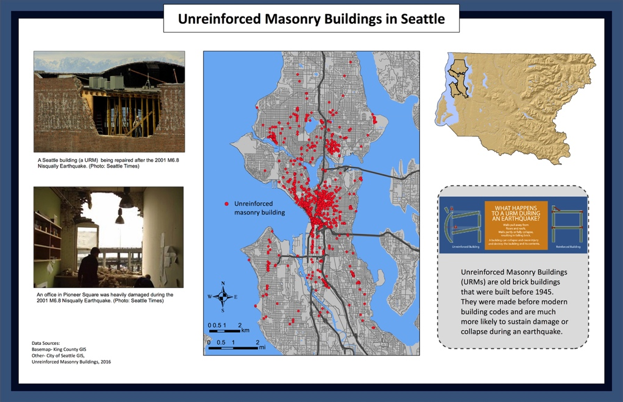

|  |  |
| --- | --- |
| 0-10/sq mile | **MUGGA AAD U HOOSEEYO: 0 illaa 10 dhismooyinka bulkeetiga (URM) dhismayaasha wareega maylkiiba**.  Dhismaha noocaan ah, dhul gariir xoogan ayaa ku sababayo darbiyada bulkeetiga ama saqafyada inay dhacaan. Haraaga wuxuu wasaqeynayaa wadooyinka. Fiiri halka URM uu [kuu dhowyahay](http://seattlecitygis.maps.arcgis.com/apps/MapSeries/index.html?appid=0489a95dad4e42148dbef571076f9b5b) iyo haddii horay loogu daray. [(qariirada)](https://hazardready.org/seattle/static/img/data/Earthquake_URM.jpg) |
| 10-25/sq mi | **MUGGA HOOSEEYO: 10 illaa 25 dhismooyinka bulkeetiga (URM) dhismayaasha wareega maylkiiba.**  Dhismaha noocaan ah, dhul gariir xoogan ayaa ku sababayo darbiyada bulkeetiga ama saqafyada inay dhacaan. Haraaga wuxuu wasaqeynayaa wadooyinka. Fiiri halka URM uu [kuu dhowyahay](http://seattlecitygis.maps.arcgis.com/apps/MapSeries/index.html?appid=0489a95dad4e42148dbef571076f9b5b) iyo haddii horay loogu daray. [(qariirada)](https://hazardready.org/seattle/static/img/data/Earthquake_URM.jpg) |
| 25-50/sq mi | **MUGGA DHEXDHAXAADKA: 25 illaa 50 dhismooyinka bulkeetiga (URM) dhismayaasha wareega maylkiiba**.  Dhismaha noocaan ah, dhul gariir xoogan ayaa ku sababayo darbiyada bulkeetiga ama saqafyada inay dhacaan. Haraaga wuxuu wasaqeynayaa wadooyinka. Fiiri halka URM uu [kuu dhowyahay](http://seattlecitygis.maps.arcgis.com/apps/MapSeries/index.html?appid=0489a95dad4e42148dbef571076f9b5b) iyo haddii horay loogu daray. [(qariirada)](https://hazardready.org/seattle/static/img/data/Earthquake_URM.jpg) |
| 50-100/sq mi | **MUGGA SAREEYO: 50 illaa 100 dhismooyinka bulkeetiga (URM) dhismayaasha wareega maylkiiba**.  Haddii aad joogtid URM inta lagu jiro Istuurka dhulgariirka, Isdabool, iyo Qabso. Dhismooyinkaan, dhul gariir xoogan ayaa ku sababayo darbiyada bulkeetiga iyo saqafyada inay dhacaan. Haraaga wuxuu wasaqeynayaa wadooyinka. Fiiri halka URM uu [kuu dhowyahay](http://seattlecitygis.maps.arcgis.com/apps/MapSeries/index.html?appid=0489a95dad4e42148dbef571076f9b5b) iyo haddii horay loogu daray. [(qariirada)](https://hazardready.org/seattle/static/img/data/Earthquake_URM.jpg) |
| 100-250/sq mi | **MUGGA AAD U SAREEYO: 100 illaa 250 dhismooyinka bulkeetiga (URM) dhismayaasha wareega maylkiiba**.  Haddii aad joogtid URM inta lagu jiro Istuurka dhulgariirka, Isdabool, iyo Qabso. Dhismooyinkaan, dhul gariir xoogan ayaa ku sababayo darbiyada bulkeetiga iyo saqafyada inay dhacaan. Haraaga wuxuu wasaqeynayaa wadooyinka. Fiiri halka URM uu [kuu dhowyahay](http://seattlecitygis.maps.arcgis.com/apps/MapSeries/index.html?appid=0489a95dad4e42148dbef571076f9b5b) iyo haddii horay loogu daray. [(qariirada)](https://hazardready.org/seattle/static/img/data/Earthquake_URM.jpg) |

## Aastaamaha Digniinta

|  |
| --- |
| Saynisyahanka ma qiyaasi karo goorta dhulgariir dhacayo marka ka taxadar iyo haddii aad dareentid gariir, istuur dabool, oo qabso. Nidaamka digniinta hore hadeer waxaa loo hormariyay Xeebta Galbeedka. Waxaad ka heli kartaa waxbadan [halkaan](http://earthquake.usgs.gov/research/earlywarning/). |

## Dhulgariirka Taariqiga ah

|  |
| --- |
| Tan iyo 1870, 15 dhulgariir weyn (oo ka weyn baaxada 5) ayaa ku dhuftay Gobolka Washington. Sheekooyinka asalka sidoo kale way sheegtaa dhulgariir weyn (oo ka weyn baaxada 8) iyo tusanaamiga ee xigay 1700. |

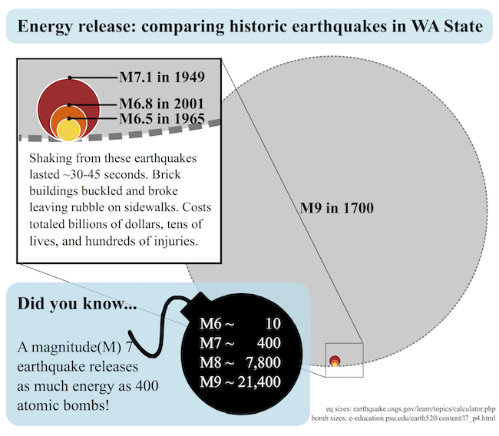

## U diyaar garow Dhulgariirka

|  |  |
| --- | --- |
| Before | 1. **DHAQANKA** - Ka taxadar oo ku dhaqan "Is tuur, Isdabool, oo Qabso" 2. **QORSHEY** - Samey qorshaha qoyska ([wixii qof weyn ah](http://www.fema.gov/media-library-data/0e3ef555f66e22ab832e284f826c2e9e/FEMA_plan_parent_508_071513.pdf) iyo [wixii carruur ah](http://www.fema.gov/media-library-data/a260e5fb242216dc62ae380946806677/FEMA_plan_child_508_071513.pdf)) oo dhis [sanduuqa saadka](http://www.seattle.gov/Documents/Departments/Emergency/Preparedness/FamilyPlans/FamilyDisasterSuppliesKitRedCross.pdf) 3. **U DIYAARGAROW** - hubi sheeyada dhici karo oo ogow goobta korontada ka dantay. |
| During | * **GUDAHA - HALKAAN JOOG!** Isku dabool hoosta miiska ama miiska ka baxsan sheeyada kugu soo dhici karo oo qabso. HA KU ordin banaanka ka hor inta uusan gariirka joogsan. * **BANAANKA - GAL MEEL BANAAN** ee ka baxsan dhismooyinka, fiilooyinka korontada, munaaradaha, ama waxyaabaha kugu soo dhici karo adiga. * **GAARI KAXEYNTA - SI TAXADAR AH U JOOGSO** (ma ahan buundo hoosteeda, buundooyinka la hoos maro, fiilooyinka korontada, iwm.) iyo JOOG GUDAHA GAARIGA. * **U DHOW XEEBTA** - Raac tilmaamaha kore illaa gariirka ka joogsado. Kadib **MADAXA OO DHUL SAREEYO**.   his is a panel of four cartoon images showing what to do during an earthquake if inside, outside, driving, or near the ocean. |
| After | **U DIYAAR GAROW NADXINTA KADIB** (dhulgariirka ee xigga naxdinta ugu weyn waa caadi ee ku sababi kartaa waxyeelo ka badan gariirka hore).   * Qadadka taleefonka way buux dhaafayaan; **fariin qoraalka waxay noqon kartaa wado wanaagsan ee lagula xiriiro qoyska.** * Ka hubi nafsadaada iyo dadka kale dhaawacyo. * Markii aad badbaado tahay, **fiir wargelinada aqbaaraha** oo dhinaca raadiyaha batariga ku shaqeeyo, telefishanada, warbaahinta bulshada, iyo digniinada qoraalka mobeelka oo warbixinta gurmadka. * Shaqaalaha gurmadka way mashquulayaan. **Waxay ku xirantahay saaxibadaada iyo dariska** oo taageerada inta lagu jiro saacadaha iyo maalmaha xigo dhulgariirka. * **Xakameynta korontada haddii ay muhiim tahay**. Wax badan ka ogow goorta iyo sida [loo xakameeyo gaaska iyo biyaha dhulgariirka kadib](http://www.seattle.gov/emergency-management/preparedness/prepare-your-home). * Daawo [fiidiyahaan](https://www.fema.gov/media-library/assets/videos/98767) si aad wax badan uga ogaatid waxa la sameynayo **INTA LAGU JIRO** iyo **KADIB** iyo dhulgariirka. |

## Xarumaha (tusaale)

|  |  |
| --- | --- |
| Local Resource | Xarumaha Gurmadka Bulshada waa meelaha dariska ay isugu imaan karaan masiibada kadib si ay usu caawiyaan.  XARUNTA ADIGA KUU DHOW WAA,  **Hope Lutheran Church (Alaska Junction Hub)**  **Goobta Xarunta: 4456 42nd Ave SW, Seattle, WA 98116**  **Xarunta Hub: Tabaruce Loo baahanyahay**  **I-meelka:** [**info@seattleemergencyhubs.org**](mailto:info@seattleemergencyhubs.org)  **Taleefonka: TBD**  **Websaydka:** [**http://seattleemergencyhubs.org**](http://seattleemergencyhubs.org/) |

# Fatahaad

## Oo noloshaada ah: Fatahaad 100 sanno

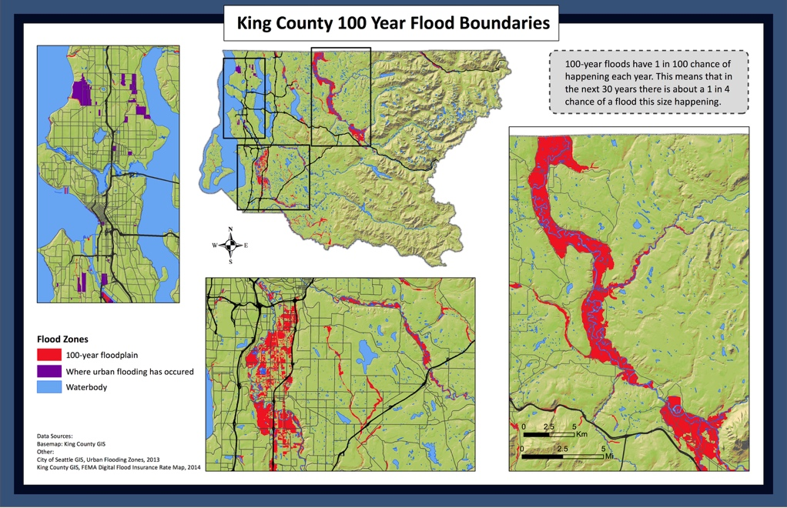

|  |  |
| --- | --- |
| River channel | **Waxaa jiro fursad sareyso ee fatahaada halkaan. Waxay fadhidaa xanuunka fatahaada 100-sanno.** Tani wxaay la micna tahay waxaa jiro 25% oo fursada biyaha fatahaada ee halkaan soo gaarayo 30-ka sanno ee xigga [(qariirada)](https://hazardready.org/seattle/static/img/data/Flood_100yr.jpg). Iska diiwaangeli digniinada fatahaada oo [i-meel ama fariin ahaan](https://green2.kingcounty.gov/floodalertsystem/) ama dajiso [app-ka digniika fatahaada](http://kingcounty.gov/services/environment/water-and-land/flooding/warning-system/app.aspx) ee mobeelada casriga ah. |
| 100-yr floodplain | **Waxaa jiro fursad sareyso ee fatahaada halkaan**. Waxay fadhidaa xanuunka fatahaada 100-sanno. Tani wxaay la micna tahay waxaa jiro 25% oo fursada biyaha fatahaada ee halkaan soo gaarayo 30-ka sanno ee xigga [(qariirada)](https://hazardready.org/seattle/static/img/data/Flood_100yr.jpg). Iska diiwaangeli digniinada fatahaada oo [i-meel ama fariin ahaan](https://green2.kingcounty.gov/floodalertsystem/) ama dajiso [app-ka digniika fatahaada](http://kingcounty.gov/services/environment/water-and-land/flooding/warning-system/app.aspx) ee mobeelada casriga ah. |
| lake or pond | **Fatahaada waa nasiib daro halkaan**. Heerarka biyaha wax yar ayay kor ukici karaan inta lagu jiro fatahaada ama duufaanta xoogan. [(qariirada)](https://hazardready.org/seattle/static/img/data/Flood_100yr.jpg) |
| reservoir | **Fatahaada waa nasiib daro halkaan**. Heerarka biya daga wax yar ayay kor ukici karaan inta lagu jiro fatahaada ama duufaanta xoogan. [(qariirada)](https://hazardready.org/seattle/static/img/data/Flood_100yr.jpg) |
| waterbody | **Fatahaada waa nasiib daro halkaan**. Heerarka biyaha wax yar ayay kor ukici karaan inta lagu jiro fatahaada ama duufaanta xoogan. [(qariirada)](https://hazardready.org/seattle/static/img/data/Flood_100yr.jpg) |
| bridge | **Buundooyinka waxay noqon karaan kuwa aan badbaado aheyn marka fatahaada dhaceyso**. Haddii aad ka shakisid in buundo waxyeelowday, ka walaacsanow oo ku soo wargeli Xarunta Digniinta Fatahaada adiga oo soo wacayo 206-296-8200 ama 800-945-9263. [(qariirada)](https://hazardready.org/seattle/static/img/data/Flood_100yr.jpg) |
| land | **Tamni waxay banaanka ka tahay aagaga fatahaada halista sareyso>** [(qariirada)](https://hazardready.org/seattle/static/img/data/Flood_100yr.jpg). LAAKIN haddii aad ku nooshahay meel u dhow ama wabi yar ka taxadar inay fatahaad noqon karto sidoo kale. Fiiri [Websaydka Wabiga iyo Maamulida Fatahaada cad](http://www.kingcounty.gov/depts/dnrp/wlr/sections-programs/river-floodplain-section.aspx) wixii warbixin dheeraad ah. |
| urban flooding | **Aagaan waxay soo fatahday xiliga la soo dhaafay markii duufaan weyn uu dhuftay Seattle**. Markale ayay dhici kartaa haddii duufaan kale oo xoogan ku sababto in biyaha u buuxsamaan oo u qalalaan si liidato. Hoos u soco oo sida la isu diyaariyo. [(qariirada)](https://hazardready.org/seattle/static/img/data/Flood_100yr.jpg) |

## Xaalada Ugu xun: Fatahaad 500 sanno

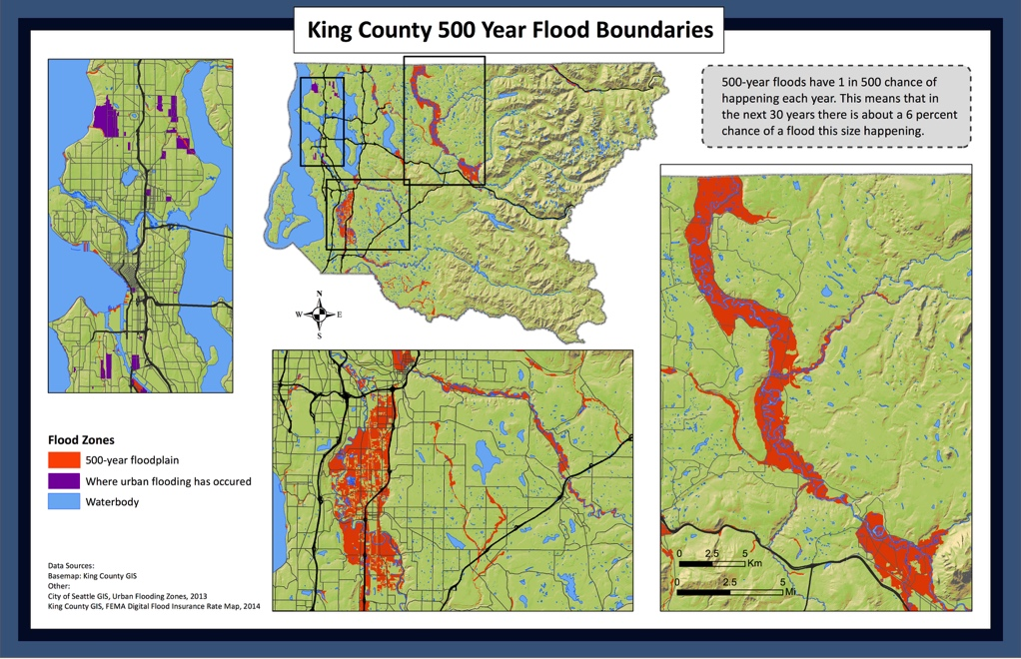

|  |  |
| --- | --- |
| River channel | Roobka, barafka dhalaalo, ama labadaba waxay ku sababaan in biyaha kor waxyar u kacaan. Biyaha fatahaada waxay buux dhaafiyaan geesaska wabiga, ku daataan dariska, oo saameeyaan wadooyinka. **Aagaan waxay ku jirtaa 500-sanno fatahaada ee qariiradeysan oo way fataheysaa.** Waxaa jiro fursada boqolkiiba 6% waxaad arkeysaa fatahaada cabirkaan ah ee 30-ka sanno ee xiggo. [(qariirada)](https://hazardready.org/seattle/static/img/data/Flood_500yr.jpg) |
| 100-yr floodplain | Roobka, barafka dhalaalo, ama labadaba waxay ku sababaan in biyaha kor waxyar u kacaan. Biyaha fatahaada waxay buux dhaafiyaan geesaska wabiga, ku daataan dariska, oo saameeyaan wadooyinka. **Aagaan ku jiro 500-sanno fatahaada cad ee qariiradeysan way fataheysaa.** Waxaa jiro fursada boqolkiiba 6% waxaad arkeysaa fatahaada cabirkaan ah ee 30-ka sanno ee xiggo. [(qariirada)](https://hazardready.org/seattle/static/img/data/Flood_500yr.jpg) |
| lake or pond | U dhow biyo dageenada, durdurada, iyo wabiyada way fatahayaan. Tani waxay ka dhigtaa wadooyinka qaarkood inaan lamari karin [(qariirada)](https://hazardready.org/seattle/static/img/data/Flood_500yr.jpg) . Iska diiwaangeli digniinada fatahaada oo [i-meel ama fariin ahaan](https://green2.kingcounty.gov/floodalertsystem/) ama dajiso [app-ka digniika fatahaada](http://kingcounty.gov/services/environment/water-and-land/flooding/warning-system/app.aspx) ee mobeelada casriga ah. |
| reservoir | **Waa nasiib daro inaad ku arkeysid fatahaad halkaan**. Duufaanta weyn waxay ku sababi kartaa meel u dhow biyo dageenada, durdurada, iyo wabiyada inay sare u kacaan. Dhacitaanka roob culus ayaa abuuri karo barkadaha biyaha taagan ee wadooyinka. Haddii aad la kulantid fatahaada deegaamowday ka soo wac Xarunta Digniinta Gobolka King 206-296-8200 ama 800-945-9263. [(qariirada)](https://hazardready.org/seattle/static/img/data/Flood_500yr.jpg) |
| waterbody | **Waa nasiib daro inaad ku arkeysid fatahaad halkaan**. Duufaanta weyn waxay ku sababi kartaa meel u dhow biyo dageenada, durdurada, iyo wabiyada inay sare u kacaan. Dhacitaanka roob culus ayaa abuuri karo barkadaha biyaha taagan ee wadooyinka. Haddii aad la kulantid fatahaada deegaamowday ka soo wac Xarunta Digniinta Gobolka King 206-296-8200 ama 800-945-9263. [(qariirada)](https://hazardready.org/seattle/static/img/data/Flood_500yr.jpg) |
| bridge | **Waa nasiib daro inaad ku arkeysid fatahaad halkaan**. Duufaanta weyn waxay ku sababi kartaa meel u dhow biyo dageenada, durdurada, iyo wabiyada inay sare u kacaan. Dhacitaanka roob culus ayaa abuuri karo barkadaha biyaha taagan ee wadooyinka. Haddii aad la kulantid fatahaada deegaamowday ka soo wac Xarunta Digniinta Gobolka King 206-296-8200 ama 800-945-9263. [(qariirada)](https://hazardready.org/seattle/static/img/data/Flood_500yr.jpg) |
| land | **Waa nasiib daro inaad ku arkeysid fatahaad halkaan**. Duufaanta weyn waxay ku sababi kartaa meel u dhow biyo dageenada, durdurada, iyo wabiyada inay sare u kacaan. Dhacitaanka roob culus ayaa abuuri karo barkadaha biyaha taagan ee wadooyinka. Haddii aad la kulantid fatahaada deegaamowday ka soo wac Xarunta Digniinta Gobolka King 206-296-8200 ama 800-945-9263. [(qariirada)](https://hazardready.org/seattle/static/img/data/Flood_500yr.jpg) |
| urban flooding | **Aagaan way unugushahay fatahaada magaalada**. Sida weyn ee duufaanta fatahaada badan ee ku arki kartid dhinacaan. [(qariirada)](https://hazardready.org/seattle/static/img/data/Flood_500yr.jpg) |

## Halista Nabaadguurka/Agaga Socdaalka Kanaalka

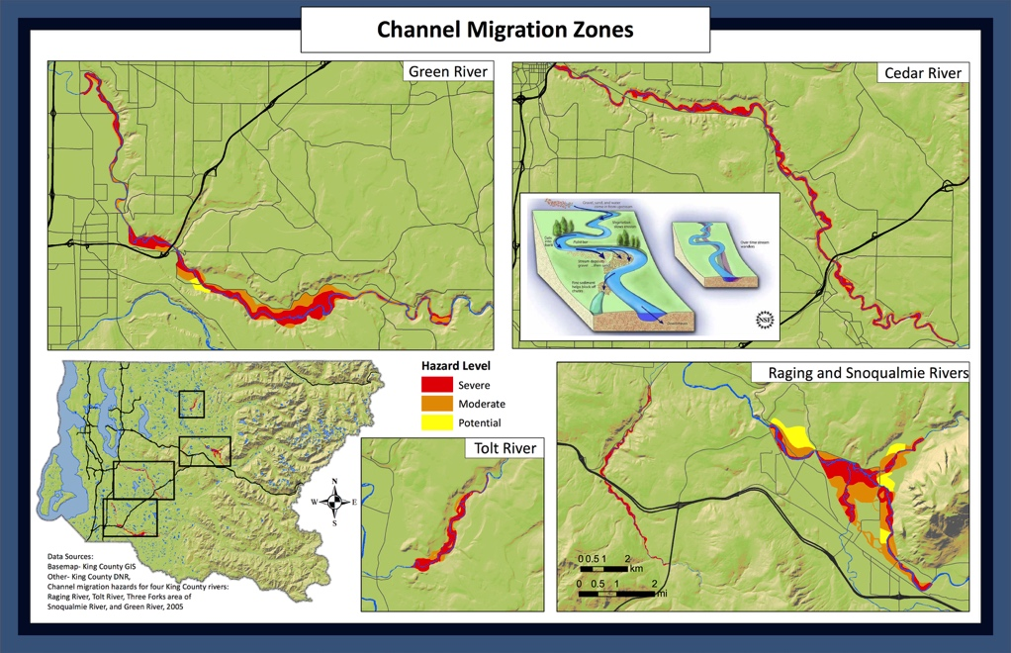

|  |  |
| --- | --- |
| Severe, Cedar River | Sida waxyaabaha ugu badan, wabiyada waxay maraan wadada diidmada iyo isbadelada waqti kadib. Waxay badelmaan inta badan inta lagu jiro iyo fahatahaada kadib. **Aagaan wuxuu leeyahay fursad sareyso ee Wabiga Cedar ee marayo dhinacaan mustaqbalka.** [(qariirada)](https://hazardready.org/seattle/static/img/data/Flood_CMZ.jpg) |
| Severe, Green River | Sida waxyaabaha ugu badan, wabiyada waxay maraan wadada diidmada iyo isbadelada waqti kadib. Waxay badelmaan inta badan inta lagu jiro iyo fahatahaada kadib. **Aagaan wuxuu leeyahay fursad sareyso ee Wabiga Green ee marayo dhinacaan mustaqbalka.** [(qariirada)](https://hazardready.org/seattle/static/img/data/Flood_CMZ.jpg) |
| Severe, Raging River | Sida waxyaabaha ugu badan, wabiyada waxay maraan wadada diidmada iyo isbadelada waqti kadib. Waxay badelmaan inta badan inta lagu jiro iyo fahatahaada kadib. **Aagaan wuxuu leeyahay fursad sareyso ee Wabiga Raging ee marayo dhinacaan mustaqbalka.** [(qariirada)](https://hazardready.org/seattle/static/img/data/Flood_CMZ.jpg) |
| Severe, Snoqualmie River | Sida waxyaabaha ugu badan, wabiyada waxay maraan wadada diidmada iyo isbadelada waqti kadib. Waxay badelmaan inta badan inta lagu jiro iyo fahatahaada kadib. **Aagaan wuxuu leeyahay fursad sareyso ee Wabiga Snoqualmie ee marayo dhinacaan mustaqbalka.** [(qariirada)](https://hazardready.org/seattle/static/img/data/Flood_CMZ.jpg) |
| Severe, Tolt River | Sida waxyaabaha ugu badan, wabiyada waxay maraan wadada diidmada iyo isbadelada waqti kadib. Waxay badelmaan inta badan inta lagu jiro iyo fahatahaada kadib. **Aagaan wuxuu leeyahay fursad sareyso ee Wabiga Tolt ee marayo dhinacaan mustaqbalka.** [(qariirada)](https://hazardready.org/seattle/static/img/data/Flood_CMZ.jpg) |
| Moderate, Cedar River | Sida waxyaabaha ugu badan, wabiyada waxay maraan wadada diidmada iyo isbadelada waqti kadib. Waxay badelmaan inta badan inta lagu jiro iyo fahatahaada kadib. **Aagaan wuxuu leeyahay fursad dhexaad ah ee Wabiga Cedar ee marayo dhinacaan mustaqbalka.** [(qariirada)](https://hazardready.org/seattle/static/img/data/Flood_CMZ.jpg) |
| Moderate, Green River | Sida waxyaabaha ugu badan, wabiyada waxay maraan wadada diidmada iyo isbadelada waqti kadib. Waxay badelmaan inta badan inta lagu jiro iyo fahatahaada kadib. **Aagaan wuxuu leeyahay fursad dhexaad ah ee Wabiga Green ee marayo dhinacaan mustaqbalka.** [(qariirada)](https://hazardready.org/seattle/static/img/data/Flood_CMZ.jpg) |
| Moderate, Raging River | Sida waxyaabaha ugu badan, wabiyada waxay maraan wadada diidmada iyo isbadelada waqti kadib. Waxay badelmaan inta badan inta lagu jiro iyo fahatahaada kadib. **Aagaan wuxuu leeyahay fursad dhaxaad ah ee Wabiga Raging ee marayo dhinacaan mustaqbalka.** [(qariirada)](https://hazardready.org/seattle/static/img/data/Flood_CMZ.jpg) |
| Moderate, Snoqualmie River | Sida waxyaabaha ugu badan, wabiyada waxay maraan wadada diidmada iyo isbadelada waqti kadib. Waxay badelmaan inta badan inta lagu jiro iyo fahatahaada kadib. **Aagaan wuxuu leeyahay fursad dhexaad ah ee Wabiga Snoqualmie ee marayo dhinacaan mustaqbalka.** [(qariirada)](https://hazardready.org/seattle/static/img/data/Flood_CMZ.jpg) |
| Moderate, Tolt River | Sida waxyaabaha ugu badan, wabiyada waxay maraan wadada diidmada iyo isbadelada waqti kadib. Waxay badelmaan inta badan inta lagu jiro iyo fahatahaada kadib. **Aagaan wuxuu leeyahay fursad dhaxaad ah ee Wabiga Tolt ee marayo dhinacaan mustaqbalka.** [(qariirada)](https://hazardready.org/seattle/static/img/data/Flood_CMZ.jpg) |
| Potential, Green River | Sida waxyaabaha ugu badan, wabiyada waxay maraan wadada diidmada iyo isbadelada waqti kadib. Waxay badelmaan inta badan inta lagu jiro iyo fahatahaada kadib. **Aagaan wuxuu leeyahay fursad hooseyso ee Wabiga Green ee marayo dhinacaan mustaqbalka.** [**(qariirada)**](https://hazardready.org/seattle/static/img/data/Flood_CMZ.jpg) |
| Potential, Snoqualmie | Sida waxyaabaha ugu badan, wabiyada waxay maraan wadada diidmada iyo isbadelada waqti kadib. Waxay badelmaan inta badan inta lagu jiro iyo fahatahaada kadib. **Aagaan wuxuu leeyahay fursad hooseyso ee Wabiga Snoqualmie ee marayo dhinacaan mustaqbalka.** [**(qariirada)**](https://hazardready.org/seattle/static/img/data/Flood_CMZ.jpg) |
| Potential, Tolt River | Sida waxyaabaha ugu badan, wabiyada waxay maraan wadada diidmada iyo isbadelada waqti kadib. Waxay badelmaan inta badan inta lagu jiro iyo fahatahaada kadib. **Aagaan wuxuu leeyahay fursad hooseyso ee Wabiga Tolt ee marayo dhinacaan mustaqbalka.** [**(qariirada)**](https://hazardready.org/seattle/static/img/data/Flood_CMZ.jpg) |
| 500 feet from river, no study completed | Sida waxyaabaha ugu badan, wabiyada waxay maraan wadada diidmada iyo isbadelada waqti kadib. **Ma jirto daraasad halkaan lagu sameeyay si loo arko haddii wabiga u dhowyahay inuu dhaqaaqo waqti kadib, laakin ogow inay noqon karto.** |
| River Channel | Tani waa gudaha kanaalka wabiga hadeer. Waqti kadib goobta kanaalka wuu isbadeli karaa. [(qariirada)](https://hazardready.org/seattle/static/img/data/Flood_CMZ.jpg) |

## Howlgabka Biyo xireenka (PMF=fatahaada ugu badnaan dhici kara, marka xaalada ugu xun)

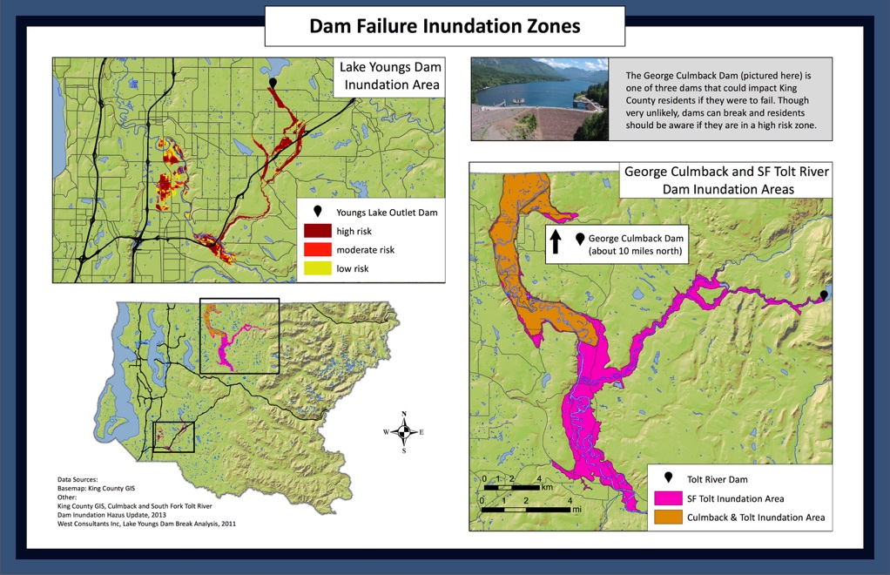

|  |  |
| --- | --- |
| Culmback Dam inundation area and tolt PMF | Howlgabka Biyo xireenka waa dhif. Si kastaba, haddii [Biyo xireenka George Culmback](https://goo.gl/maps/X2HGtZX6Kyz) ama [Biyo xireenka Wabiga Tolt](https://goo.gl/maps/DpotpRjYDvG2) howlgabo aagaan way fatahi kartaa [(qariirada)](https://hazardready.org/seattle/static/img/data/Flood_DamInundation.jpg). Iska diiwaangeli digniinada fatahaada oo [i-meel ama fariin ahaan](https://green2.kingcounty.gov/floodalertsystem/) ama dajiso [app-ka digniika fatahaada](http://kingcounty.gov/services/environment/water-and-land/flooding/warning-system/app.aspx) ee mobeelada casriga ah. |
| Lake Youngs dam low | Howlgabka Biyo xireenka waa dhif. Si kastaba, haddii [Biyo xireenka Haraha Youngs](https://goo.gl/maps/RMaHnAY8RCp) howlgabo aagaan waxay halis ugu jirtaa fatahaad [(qariirada)](https://hazardready.org/seattle/static/img/data/Flood_DamInundation.jpg). Iska diiwaangeli digniinada fatahaada oo [i-meel ama fariin ahaan](https://green2.kingcounty.gov/floodalertsystem/) ama dajiso [app-ka digniika fatahaada](http://kingcounty.gov/services/environment/water-and-land/flooding/warning-system/app.aspx) ee mobeelada casriga ah. |
| Lake youngs dam moderate | Howlgabka Biyo xireenka waa dhif. Si kastaba, haddii [Biyo xireenka Haraha Youngs](https://goo.gl/maps/RMaHnAY8RCp) howlgabo aagaan waxay halis ugu jirtaa fatahaad dhexdhaxaad ah [(qariirada)](https://hazardready.org/seattle/static/img/data/Flood_DamInundation.jpg). Iska diiwaangeli digniinada fatahaada oo [i-meel ama fariin ahaan](https://green2.kingcounty.gov/floodalertsystem/) ama dajiso [app-ka digniika fatahaada](http://kingcounty.gov/services/environment/water-and-land/flooding/warning-system/app.aspx) ee mobeelada casriga ah. |
| Lake youngs dam high | Howlgabka Biyo xireenka waa dhif. Si kastaba, haddii [Biyo xireenka Haraha Youngs](https://goo.gl/maps/RMaHnAY8RCp) howlgabo aagaan waxay halis ugu jirtaa sareyso ugu jirtaa fatahaad [(qariirada)](https://hazardready.org/seattle/static/img/data/Flood_DamInundation.jpg). Iska diiwaangeli digniinada fatahaada oo [i-meel ama fariin ahaan](https://green2.kingcounty.gov/floodalertsystem/) ama dajiso [app-ka digniika fatahaada](http://kingcounty.gov/services/environment/water-and-land/flooding/warning-system/app.aspx) ee mobeelada casriga ah. Howlgabka Biyo xireenka waa dhif. |
| South Fork Tolt River Dam | Howlgabka Biyo xireenka waa dhif. Si kastaba, haddii [Biyo xireenka Wabiga Tolt](https://goo.gl/maps/DpotpRjYDvG2) aagaan way fatahi kartaa [(qariirada)](https://hazardready.org/seattle/static/img/data/Flood_DamInundation.jpg). Iska diiwaangeli digniinada fatahaada oo [i-meel ama fariin ahaan](https://green2.kingcounty.gov/floodalertsystem/) ama dajiso [app-ka digniika fatahaada](http://kingcounty.gov/services/environment/water-and-land/flooding/warning-system/app.aspx) ee mobeelada casriga ah. |

## Saameynada Cimilada

|  |
| --- |
| Duufaanada daran waxaa laga filanayo inay kordhiso 50-ka sanno ee xigga. Waxay u keeneysaa roob iyo baraf. Wabiyada waxay yeelanayaan qulqul sareeyo ee u jaheynayo fatahaad badan ee Deyrta/Qaboobaha. Riix sawirka lagu ogaanayo wax badan.  [limate Change Rivers Infographic](http://kingcounty.gov/services/environment/climate/why-act/infographic.aspx) |

## Aastaamaha Digniinta

|  |
| --- |
| Miyuu roob adag da’ayay ama maalmo badan? Leeyahay heer kulul kacayo oo sababay baraf dhallaalka lama filaanka ah ee buuraha? Samey heerarka biyaha ee wabiyada deegaanka ee sare u muuqdo? Fursadaha fatahaada way kordhi kartaa. Fiiri wargelinada aqbaarta oo adeegyada cimilada ee digniinada deegaanka. |

## U diyaargarow Fatahaada

|  |  |
| --- | --- |
| Before | 1. **QORSHEY** - Samey qorshaha waxa la sameynayo iyo halka la aadayo haddii ay biyaha soo koraan. **La how sheeyo muhiim ah oo diyaar ah** (shahaadooyinka dhalashada, waraaqaha muhiimka ah, sawirada, iwm). Hel caymiska fatahaada haddii aad u baahantahay. 2. **U DIYAARGAROW** - Ku keydso sheeyada qiimaha leh iyo kiimikooyinka qoyska meel ka koreyso heerarka fatahaada iyo **baro sida loo damiyo korontooyinka** ([biyaha, gaaska, iyo korontada](http://www.seattle.gov/emergency-management/preparedness/prepare-your-home)). |
| During | * **DIYAAR GAROW** - Isu keen sheeyada degdega ah (dharka diiran, toosh, mobeel, raadiyow la qaadi karo, iwm). Haddii waqtiga ogolaado oo wuxuu u muuqdaa muhiim, dami korontooyinka * **DHAGEYSO** - Dhageyso aqbaaraha iyo haddii laguugula taliyo, u guur dhul sareeyo. * **KA FOGOW HALISAHA - HA ku lugeynin ama haku kaxeynin dhinaca biyaha fatahaada**. Waxay qaadataa kaliya 6 injis oo dhaqaaqa biyaha ee adiga kugu dhufunayo iyo 2 fiit oo gaariga loogu xaaqayo!   his is a panel of four cartoon images showing what to do during an a flood colect essentials, get to high ground, avoid water, and shutt off utilities. |
| After | * Haddii gurigaaga fatahay, **ka walaacsanow dib u gelida sida ay lahaan karto waxyeelo qaabeysan**. * **Lahow korontooyinka eegida xirfadlaha** ka hor inta aadan iska geddin. * **Lumitaanada waraaqaha** ee sawirida waxyeelooyinka iyo qarashaadka suubinta duubitaanka. * Ka ogow wax badan [**halkaan**](http://www.kingcounty.gov/services/environment/water-and-land/flooding/prepare.aspx). |

## Illaha Deegaanka

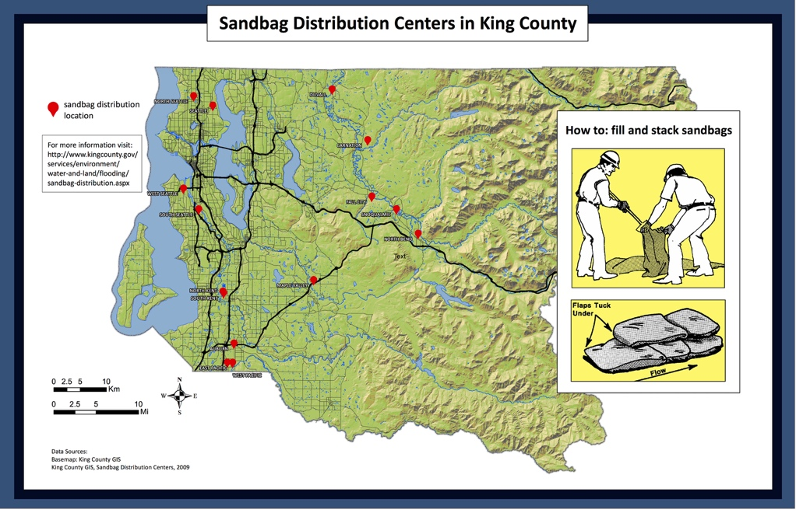

illaha: Gobolka King GIS, 2009, Goobaha Qeybinta Jawaanada ciida ee Gobolka King, <http://www5.kingcounty.gov/sdc/DataImages/sandbag_distribution_location.jpg>.

|  |  |
| --- | --- |
| Kent (example) | U diyaar garow fatahaada adiga oo qaadayo oo buuxinayo jawaanada ciida. [(qariirada)](https://hazardready.org/seattle/static/img/data/Flood_Sandbag_Distr_Centers.jpg)  QEYBIN XARUNTA KUU DHOW ADIGA WAA,  **Russell Road Park**  **u dhaxeyso Russell Rd. iyo S. 240th St.**  **Kent, WA, 98032**  **Ciida qaado kaliya (ma lahan jawaanka ciida)**  **Isniinta-Jimcaha 8:00 am - 4:00 pm** |

## Fatahaadaha Taariiqiga ah

|  |
| --- |
| Oo leh wabiyaal badan ee fatahaada Gobolka King waa caadi inta lagu jiro muddooyinka dhacitaanada roobka culus ama baraf dhallaalka degdega ah. **Fatahaada way ugu caadisantahay ka bilow Nofeembarta illaa Febraayo**, laakin waxay dhici kartaa marwalba oo xaaladaha ay saxanyihiin. |

# Dhulal buurta/Lumitaanka Weyn

## Oo noloshaada ah: Aaga Taraaraxa Imaan karta

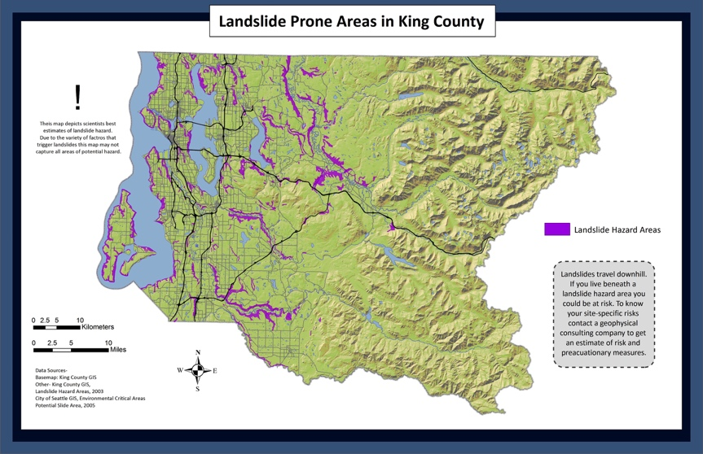

|  |  |
| --- | --- |
| Shallow Slope | **Aagaan waxay leedahay giirada godka oo waxay si yar ugu dhowdsahay inay yeelato dhulalka buurta ah halkaan**. Dhulalka buuraha u muuqdaan inay ka dhacaan markii dhulka uu ka qoyanyahay qeybaha roobka AMA dhulka gariirka sababo. Hoos uga soco dhacdooyinka taariiqiga ah fiiri haddii wax dhulalka buurta ah lagu qoray aagaaga. ([qariirada](https://hazardready.org/seattle/static/img/data/Landslide_SteepSlope.jpg)) |
| Steep Slope | **Sabab la xiriirto dalcadaha dagaandaga, aagaan waxay leedahay fursad dheeraad ah ee godka dhulalka buurta ah halkaan**. Dhulalka buuraha u muuqdaan inay ka dhacaan markii dhulka uu ka qoyanyahay qeybaha roobka AMA dhulka gariirka sababo. Hoos uga soco dhacdooyinka taariiqiga ah si aad u aragtid dhulka buurta lagu qoray aagaaga. ([qariirada](https://hazardready.org/seattle/static/img/data/Landslide_SteepSlope.jpg)) |
| Steep Slope | **Sabab la xiriirto dalcadaha dagaandaga, aagaan waxay leedahay fursad dheeraad ah ee godka dhulalka buurta ah halkaan**. Dhulalka buuraha u muuqdaan inay ka dhacaan markii dhulka uu ka qoyanyahay qeybaha roobka AMA dhulka gariirka sababo. Hoos uga soco dhacdooyinka taariiqiga ah si aad u aragtid dhulka buurta lagu qoray aagaaga. ([qariirada](https://hazardready.org/seattle/static/img/data/Landslide_SteepSlope.jpg)) |

**Xaalada Ugu xun: Socodka Imaan karta**

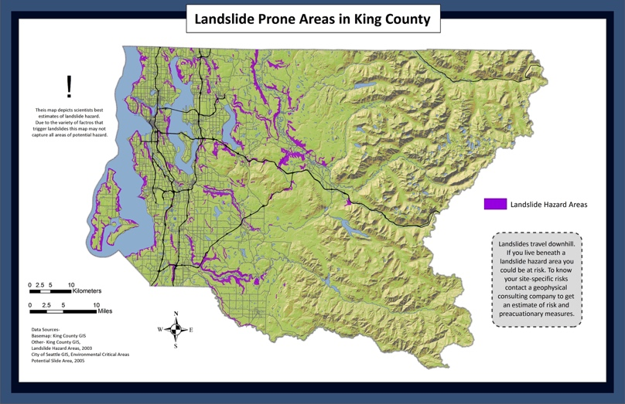

|  |  |
| --- | --- |
| Shallow slope | **Lagama yaabo inaad ku aragtid taraarax halkaan, laakin waxaad ku arki kartaa mid u dhow dalcadaha dagaandaga haddii xaaladaha ay saxantahay.** Isha ku hay aagaga aan xasilooneyn. Gaar ahaan wadooyinka ay xireen haraayada ama xaalufay. [(qariirada)](https://hazardready.org/seattle/static/img/data/Landslide_SteepSlope.jpg) |
| Steep slope | Miyay dalcadaha dagaandaga u dhowyihiin meel aan qudaar ka bixin? Miyuu roob da’ayay maalmo? **Haddii ay haa tahay, dalcadaha dagaandaga ka dhig si ay aad ugu dhowdahay dhulka buurta ah inay halkaan ka dhacdo**. Isha ku hay aagaga aan xasilooneyn. Gaar ahaan wadooyinka ay xireen haraayada ama xaalufay. [(qariirada)](https://hazardready.org/seattle/static/img/data/Landslide_SteepSlope.jpg) |
| Steep slope | Miyay dalcadaha dagaandaga u dhowyihiin meel aan qudaar ka bixin? Miyuu roob da’ayay maalmo? **Haddii ay haa tahay, dalcadaha dagaandaga ka dhig si ay aad ugu dhowdahay dhulka buurta ah inay halkaan ka dhacdo**. Isha ku hay aagaga aan xasilooneyn. Gaar ahaan wadooyinka ay xireen haraayada ama xaalufay. [(qariirada)](https://hazardready.org/seattle/static/img/data/Landslide_SteepSlope.jpg) |

## Saameynada Cimilada

|  |
| --- |
| Dhulalka buurta ah waxy inta badan ka dhacdaa illaa taraaraxa xeebta hore ee hirarka ku dhufanayo leemanka xeebta. **Biyaha Puget Sound waxay ka kaceen 8 injis tan iyo 1913**! Oo leh heerarka biyaha sareeyo ee nabaadguurka hore ee imaan karo way kordhayaan. Roobka xad dhaafka ee duufaanada daran waxay sidoo kale yareyn karaan dalcadaha ee kicinayo dhulalka buurta badan ee Gobolka King. Riix sawirka lagu ogaanayo wax badan.  [limate Change Storms Infographic](http://kingcounty.gov/services/environment/climate/why-act/infographic.aspx) |

## Aastaamaha Digniinta

|  |
| --- |
| Miyaad maqashaa dhawaqyada alwaaxa dilaacayo, dhagaxaan isgaraacayo, guuxa dhulka? Ma aragtaa jeexyada muuqaalka dhulka iyo dhaqaaqa dalcadaha hoose ee dhulka, dhagaxaanta, iyo qudaarta? Waxay noqon kartaa dhulka buurta ah. U dhaqaaq dhul xasiloon. |

## U diyaar garow dhulka buurta

|  |  |
| --- | --- |
| Before | 1. **QIIMEY** - Haddii aaga agagaarka gurigaaga laga yaabo inuu u nugulyahay dhulalka buurta **raadi tallada taqasusyada dhulka**. Waxay qiimeyn karaan halista dhulka buurta iyo/ama naqshada farsamooyinka saxitaanka ee lagu yareynayo dhulalka buurta. 2. **YAREY HALISTA** - Abuur daboolka dhulka ee jiirada iyo/ama dhis darbi celinayo ee xasilinayo **dhinacyada buurta** 3. **DIYAARI** - **Samey sanduuqa saadka iyo qorshaha qoyska** oo naqshadeynayo ugu yaraan labo wadooyin badbaado ah |
| During | **Ka joogitaanka wadada dhulka buurta ama haraaga waa illaaladaada ugu wanaagsan.** Sahanka Dhulka Mareykanka sidoo kale wuxuu ku taliyay sida xigta,   * **KA DIGTOONOW - Dhageyso dhawaqyada aan caadiga aheyn**. Xoogan, kala go’a gaaban ee roobka waxay noqon kartaa halis gaar ah, gaar ahaan muddooyin dheer kadib ee dhacitaanka roobka xoogan iyo cimilada qoyan. * **TIXGELI KA TAGIDA** - Haddii aad joogtid aagaga ee unugul dhulalka buurta ah iyo qulqulada haraaga, tixgeli ka tagida haddii ay badbaado tahay inaad sidaas sameysid. Haddii aad go'aansatid inaad guriga joogtid, u dhaqaaq sheekada labaad haddii ay suurtogal tahay. * **OGOW HEERARKA DURDURKA** - Haddii aad u dhowdahay durdur ama kanaal, **ka digtoonow kordhin walboo lama filaan ah ama hoos u dhaca qulqulka biyaha iyo isbadelka biyaha cad oo dhoobo noqonayo**. Kuwaan waxay tilmaami kartaa durdurka kore ee howsha dhulka buurta ah. HAKA DAAHIN! Keydi nafsadaada, ma ahan alaabahaaga.   Waxaad ka heli kartaa dhulalka buurta ah oo badan USGS [halkaan](http://landslides.usgs.gov/learn/prepare.php). his is a panel of three cartoon images showing what to do during a landslide if indoors, near slide, or in slide |
| After | **U DIYAAR AHOW FATAHAADA (dhulka buurta ah inta badan waxaa xiro wabiyada oo waxay ku sababi karaan wabiyada inay dib u laabtaan oo fatahaan)**.   * Ka fogow taraaraxa. Taraaraxyada kale waxay dhici karaan kadib taraaxada guud. * Marka ay badbaado tahay, ka hubi dadka dhaawacmay ama xanibmay. * Ka hubi waxyeelada leemanka korontada oo soo wargeli waxyeelo walba shirkadaada korontada. * Dhageyso warbaahinta deegaanka ama raadiyowga Cimilada NOAA oo warbixinta hadeer ah. |

## Illaha Deegaanka

|  |  |
| --- | --- |
| Landslide Resources | Wixii warbixin dheeraad ah ka fiiri bogga Waaxda Illaha Dabiiciga ee [dhulalka buurta](http://www.dnr.wa.gov/programs-and-services/geology/geologic-hazards/landslides#some-historic-landslides-in-washington-state) iyo [halisaha dhulalka buurta ah](http://file.dnr.wa.gov/publications/ger_fs_landslide_hazards.pdf). Wixii dhulalka buurta ee xaafadaada, fiiri warbixin laha heli karo Seattle iyo Gobolka King.  [Gobolka King](http://www.kingcounty.gov/services/environment/water-and-land/landslides.aspx)  [Caasimada Seattle](http://www.seattle.gov/dpd/aboutus/whoweare/emergencymanagement/) |

## Taariiqda hadeer ah

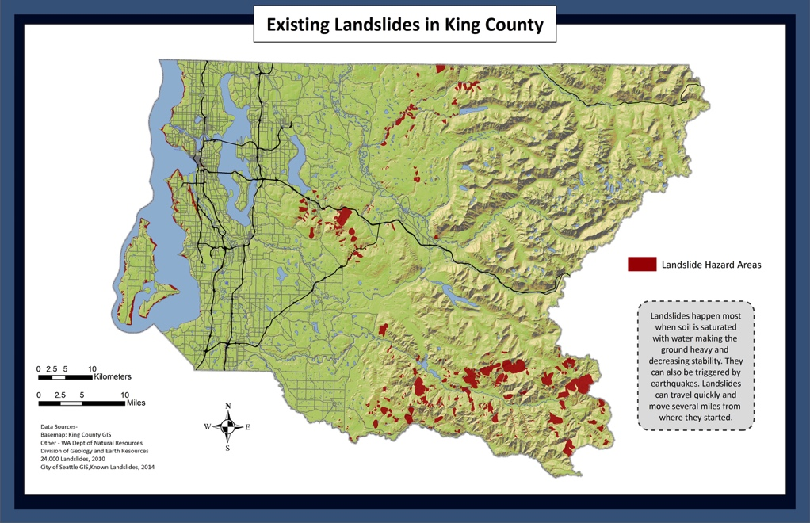

|  |  |
| --- | --- |
| 1 | **Ma jiraan dhulalka buurta oo halkaan lagu aqoonsaday** ([Wargelinta](http://www.kingcounty.gov/%7E/media/services/gis/documents/DPER-LS-hazard-map-report.ashx?la=en) 2016). Dhulalka buurta caadi ayay ka yihiin dhal la’aanta, dalcadaha dagaandaga halka daadashooyinka isugu imaadaan. Haddii aad ku nooqshahay meel ka hooseyso aaga sida midaan ka taxadar halisahaaga ([qariirada](https://hazardready.org/seattle/static/img/data/Landslide_existing.jpg=en)). Si loogu baaro fadhiyada xogta si aad u dhow ee [Gobolka King iMap](https://gismaps.kingcounty.gov/iMap/) (iska hubi dhulalka buurta in lagu eego sheekada). |
| 2 | **Saynisyahanada kama aqoonsan wax dhul gariir ah halkaan.** Wixii warbixin dheeraad ah fiiri [Wargelinta 2016](http://your.kingcounty.gov/dnrp/library/2016/kcr2783.pdf) iyo [qariirada](https://hazardready.org/seattle/static/img/data/Landslide_existing.jpg). Si loogu baaro fadhiyada xogta si aad u dhow ee [Gobolka King iMap](https://gismaps.kingcounty.gov/iMap/) (iska hubi dhulalka buurta in lagu eego sheekada). |
| 3 | **Ma jiraan dhulalka buurta ee lagu aqoonsaday halkaan** sida waafaqsan daraasada 1995 ee taraaraxa Caasimafa Seattle ([qariirada](https://hazardready.org/seattle/static/img/data/Landslide_existing.jpg=en)). |
| 4 | **Ma jiraan daraasad lagu dhameystiray halkaan** ee lagu aqoonsanayo haddii dhulalka buurta taariiq ahaan jireen ([qariirada](https://hazardready.org/seattle/static/img/data/Landslide_existing.jpg=en)). |
| 1a | **DHULALKA BUURTA WAXAY KA DHACDAY HALKAAN** ee waqti yar ee la soo dhaafay ([Wargelinta 2016](http://your.kingcounty.gov/dnrp/library/2016/kcr2783.pdf)) iyo ([qariirada](https://hazardready.org/seattle/static/img/data/Landslide_existing.jpg=en)). Taraaraxyada taariiqiga ah laga yaabo ama laga yaabin inay tilmaanto taraaraxa mustaqbalka dhici karo. Si loo ogaado haddii halisaha weli ka jiraan aaga baahiyada qiimeynta gaarka ah ee uu sameynayo la taliyaha farsamada dhulka. Si loogu baaro fadhiyada xogta si aad u dhow ee [Gobolka King iMap](https://gismaps.kingcounty.gov/iMap/) (iska hubi dhulalka buurta in lagu eego sheekada). |
| 1b | **DHULALKA BUURTA WAXAY KA DHACDAY HALKAAN** ee waqti yar ee la soo dhaafay ([Wargelinta 2016](http://your.kingcounty.gov/dnrp/library/2016/kcr2783.pdf)) iyo ([qariirada](https://hazardready.org/seattle/static/img/data/Landslide_existing.jpg=en)). Taraaraxyada taariiqiga ah laga yaabo ama laga yaabin inay tilmaanto taraaraxa mustaqbalka dhici karo. Si loo ogaado haddii halisaha weli ka jiraan aaga baahiyada qiimeynta gaarka ah ee uu sameynayo la taliyaha farsamada dhulka. Si loogu baaro fadhiyada xogta si aad u dhow ee [Gobolka King iMap](https://gismaps.kingcounty.gov/iMap/) (iska hubi dhulalka buurta in lagu eego sheekada). |
| 2a | **DHULALKA BUURTA WAXAY KA DHACDAY HALKAAN** ee waqti yar ee la soo dhaafay ([Wargelinta 2016](http://your.kingcounty.gov/dnrp/library/2016/kcr2783.pdf)) iyo ([qariirada](https://hazardready.org/seattle/static/img/data/Landslide_existing.jpg=en)). Taraaraxyada taariiqiga ah laga yaabo ama laga yaabin inay tilmaanto taraaraxa mustaqbalka dhici karo. Si loo ogaado haddii halisaha weli ka jiraan aaga baahiyada qiimeynta gaarka ah ee uu sameynayo la taliyaha farsamada dhulka. Si loogu baaro fadhiyada xogta si aad u dhow ee [Gobolka King iMap](https://gismaps.kingcounty.gov/iMap/) (iska hubi dhulalka buurta in lagu eego sheekada). |
| 2b | **DHULALKA BUURTA iyo DHACITAANKA DHAGAXA WAXAY KA DHACDAY HALKAAN** ee waqti yar ee la soo dhaafay ([Wargelinta 2016](http://your.kingcounty.gov/dnrp/library/2016/kcr2783.pdf)) iyo ([qariirada](https://hazardready.org/seattle/static/img/data/Landslide_existing.jpg=en)). Taraaraxyada taariiqiga ah laga yaabo ama laga yaabin inay tilmaanto taraaraxa mustaqbalka dhici karo. Si loo ogaado haddii halisaha weli ka jiraan aaga baahiyada qiimeynta gaarka ah ee uu sameynayo la taliyaha farsamada dhulka. Baar fadhiyada xogta si aad u dhow ee [Gobolka King iMap](https://gismaps.kingcounty.gov/iMap/) (iska hubi dhulalka buurta in lagu eego sheekada). |
| 2c | **DHACITAANKA DHAGAXA WAXAY KA DHACDAY HALKAAN** ee waqti yar ee la soo dhaafay ([Wargelinta 2016](http://your.kingcounty.gov/dnrp/library/2016/kcr2783.pdf)) iyo ([qariirada](https://hazardready.org/seattle/static/img/data/Landslide_existing.jpg=en)). Taraaraxyada taariiqiga ah laga yaabo ama laga yaabin inay tilmaanto taraaraxa mustaqbalka dhici karo. Si loo ogaado haddii halisaha weli ka jiraan aaga baahiyada qiimeynta gaarka ah ee uu sameynayo la taliyaha farsamada dhulka. Baar fadhiyada xogta si aad u dhow ee [Gobolka King iMap](https://gismaps.kingcounty.gov/iMap/) (iska hubi dhulalka buurta in lagu eego sheekada). |
| 3a | **DHULALKA BUURTA WAXAY KA DHACDAY HALKAAN** sida waafaqsan daraasada 1995 ee tararaxyada Caasimada Seattle ([qariirada](https://hazardready.org/seattle/static/img/data/Landslide_existing.jpg=en)). Taraaraxyada taariiqiga ah laga yaabo ama laga yaabin inay tilmaanto taraaraxa mustaqbalka dhici karo. Si loo ogaado haddii halisaha weli ka jiraan aaga baahiyada qiimeynta gaarka ah ee uu sameynayo la taliyaha farsamada dhulka. |

# Dabka duurka

## Oo noloshaada ah: Bulshooyinka WUI

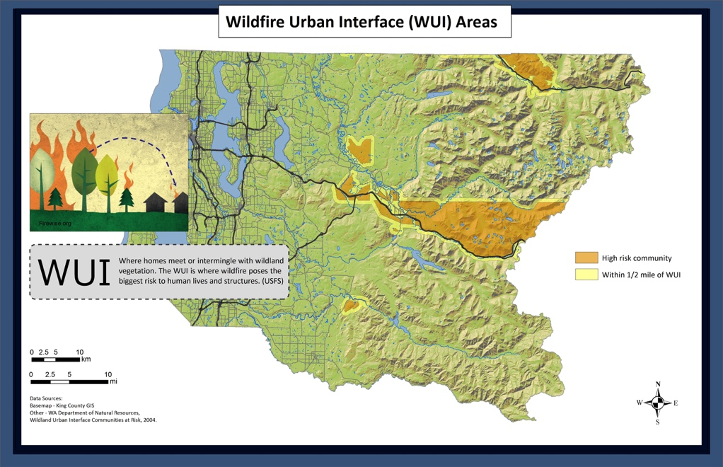

|  |  |
| --- | --- |
| Extreme | **Kani waa bulsho halis aad u sareyso ugu jirto dabka duurka**. Waa xaduuda u dhaxeyso aadanaha iyo duurka. Galbeedka Washington waa heer kulul, laakin dabka duurka waxay ku dhuftaan qeybta bariga ee Gobolka King sannad walba. [(qariirada)](https://hazardready.org/seattle/static/img/data/Wildfire_WUI.jpg) |
| high | **Kani waa bulsho halis sareyso ugu jirto dabka duurka**. Waa xaduuda u dhaxeyso aadanaha iyo duurka. Galbeedka Washington waa heer kulul, laakin dabka duurka waxay ku dhuftaan qeybta bariga ee Gobolka King sannad walba. [(qariirada)](https://hazardready.org/seattle/static/img/data/Wildfire_WUI.jpg) |
| half mile buffer around WUI | **Aagaan looma aqoonsan sida inay leedahay halis sareyso ee dabka duurka**, laakin waxay ku taalaa gudaha mayl barkiisa ee bulshada halista sareyso. Xaaladaha wanaagsan dabka duurka wuu faafayaa. [(qariirada)](https://hazardready.org/seattle/static/img/data/Wildfire_WUI.jpg) |
| King County outside WUI and Buffer | **Aagaan waxay leedahay halis hooseyso aad u hoseyso ee dabka duurka**. Haddii aad ku nooshahay meel u dhow aaga alwaaxda ka taxar dabka duurka wuu dhici karaa. [(qariirada)](https://hazardready.org/seattle/static/img/data/Wildfire_WUI.jpg) |
| Water | **Sida tani ay tahay biyo, ma jiraan filashada dabka duurka ee ka jiray halkaan**. [(qariirada)](https://hazardready.org/seattle/static/img/data/Wildfire_WUI.jpg) |

## Xaalada ugu xun



|  |  |
| --- | --- |
| extreme | **Waxaad kala kulmi kartaa dabka duurka oo weyn halkaan**. Waxay noqoneysaa dhaqaaqa dheereeyo, ee la jiro holac weyn oo dhaqso ayuu badeli karaa jahada. Waxay ku qaadan kartaa dab damiyayaasha maalmo ama isbuucyo inay damiyaan. QIIQA ka imaanayo baaxada dabka duurka wuu safri karaa oo waxay xaqiiq u noqon kartaa xittaa haddii waxba aan ku gubaneynin meel kuu dhow. Ka hubi tayada hawadaa deegaankaaga [halkaan](http://www.pscleanair.org/airquality/ourairquality/Pages/default.aspx). |
| high | **Waxaad kala kulmi kartaa dabka duurka oo weyn halkaan**. Waxay noqoneysaa dhaqaaqa dheereeyo, ee la jiro holac weyn oo dhaqso ayuu badeli karaa jahada. Waxay ku qaadan kartaa dab damiyayaasha maalmo ama isbuucyo inay damiyaan. QIIQA ka imaanayo baaxada dabka duurka wuu safri karaa oo waxay xaqiiq u noqon kartaa xittaa haddii waxba aan ku gubaneynin meel kuu dhow. Ka hubi tayada hawadaa deegaankaaga [halkaan](http://www.pscleanair.org/airquality/ourairquality/Pages/default.aspx). |
| half mile buffer around WUI | **Waxaad kala kulmi kartaa dabka duurka halkaan**. Waxay noqoneysaa dhaqaaqa dheereeyo, ee la jiro holac weyn oo dhaqso ayuu badeli karaa jahada. Waxay ku qaadan kartaa dab damiyayaasha maalmo ama isbuucyo inay damiyaan. QIIQA ka imaanayo baaxada dabka duurka wuu safri karaa oo waxay xaqiiq u noqon kartaa xittaa haddii waxba aan ku gubaneynin meel kuu dhow. Ka hubi tayada hawadaa deegaankaaga [halkaan](http://www.pscleanair.org/airquality/ourairquality/Pages/default.aspx). |
| King County outside WUI and Buffer | **Uma badna, laakin haddii aad ku nooshahay meel u dhow aaga duurka ah waxaad la kulmi kartaa dabka duurka**. QIIQA ka imaanayo baaxada dabka duurka wuu safri karaa oo waxay xaqiiq u noqon kartaa xittaa haddii waxba aan ku gubaneynin meel kuu dhow. Ka hubi tayada hawadaa deegaankaaga [halkaan](http://www.pscleanair.org/airquality/ourairquality/Pages/default.aspx). |

## Saameynada Cimilada

|  |
| --- |
| Tirada **dabka duurka ee Badda Wuqooyiga galbeed marhore ayay si weyn u korodhay labaatankii sanno ee la soo dhaafay**. Isbedalkaan wuxuu u dhowyahay inuu ku sii socdo kuleelo qalalan oo duufaan badan (ka fakir daarida dhimbilaha dabkaas). Aagaga weyn ee duurka wuu guban karaa oo qiiq gelin karaa hawada. Riix sawirka lagu ogaanayo wax badan.  [limate Change Forest Infographic](http://kingcounty.gov/services/environment/climate/why-act/infographic.aspx) |

## Aastaamaha Digniinta

|  |  |
| --- | --- |
| Warning signs | Ma urineysaa ama ma aragtaa qiiq? Miyay balaaratay abalaaratay cimilada qalalan? Waxay noqon kartaa dabka duurka. Si cad uga tala bixi dabka firfircoon iyo haddii aad aragtid mid soo wac 9-1-1 si aad usoo wargelisid. |

## U diyaar garowga Dabka Duurka

|  |  |
| --- | --- |
| Before | 1. **BOOS SAMEEY** - Ka illaali nololaha iyo hantiyada adiga oo aasaasayo **boos dabka qabsado ee agagaarka gurigaaga**, harka, iyo ganacsiga. Si aad u ogaatid sida ka fiiri [firewise.org](http://www.firewise.org/wildfire-preparedness.aspx). 2. **DAAWO CIMILADA** - Dhoor maalmood qurax ah waxay ku qalali karaan duurarkeena oo ku filan inay dab qabsadaan. Xaalada dabeysha waxay ku sababi kartaa dabka duurka in la xakameyn waayo durbadiiba.his is an image of ways to prevent wildfire around your home. They include screening decks, pruning trees 6-10 feet from the ground, using fire-resistant wall and roof materials, keeping plants watered, and making sure your driveway can accommodate an emergency vehicle |
| During | * **DIGTOONOW** - Ka dhageyso digniinada degdega deegaanka raadiyowga iyo/ama talefishanka oo u diyaargarow inaad ka badbaadid haddii ay muhiim tahay. * **KA SAAR WAXYAABAHA GUBAN KARO** - Ka saar alaabaha agaagrka guriga ee ay ku qabsan karaan dabka (kuraasta cowska ah, miisaska, iwm.). * **DIYAARGAREE GURIGAAGA** - Dhaqaaji ka dabool alaabah guriga daaqadaha. Xir albaabada iyo daaqadaha, laakin ha xirin iyaga.   his is an icon of an exclaimation point with two triangles behind it |
| After | * Gurigaaga ku laabo markii maamulada ay dhahaan waa badbaado. * **Isticmaal taxadarka marka aad galeysid aagaga guban** sida halisaha ay weli jiri karto. * Fiiri iyo dib u fiiri qiiqa ama dhimbilaha qarsoon. * **Sawir waxyeelada** oo ujeedooyinka caymiska. |

## Illaha Deegaanka

|  |  |
| --- | --- |
| Fire Resources | Haddii aad u maleysay in hantidaada ay halis ku jrii karto **Gobolka King wuxuu hayaa warbixinta milkiilayaasha dhulka, barnaamijyada dhiirogelinta, iyo aqoon isweedaarsiyada tababarka la martigeliyay**. Waxaad ka heli kartaa waxbadan [halkaan](http://www.kingcounty.gov/environment/water-and-land/forestry.aspx). |

## Taariiqda Hadeer

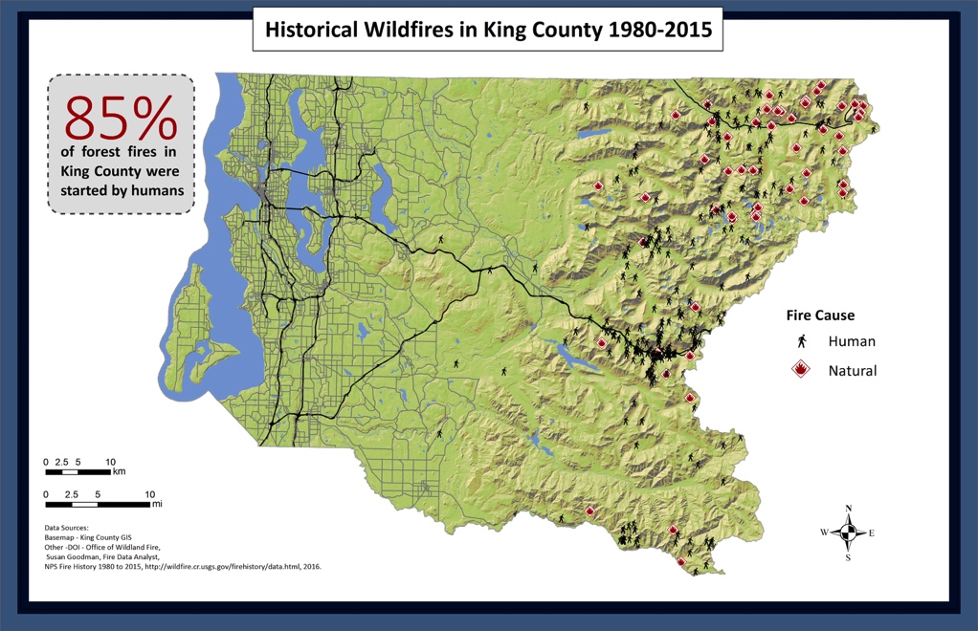

|  |  |
| --- | --- |
| Fire History | Bariga Gobolka King wuxuu leeyahay dabka yar ee duurka ah sannad walba. Caadi ahaan aadanaha ayaa sababay. Fiiri halka dabka ka dhacay xiliga la soo dhaafay adiga oo riixayo [halkaan](https://hazardready.org/seattle/static/img/data/Wildfire_Historic.jpg). |

# Foolkaanada

## Inta badan-Ugu dhow: Ma jirto Qarax

|  |
| --- |
| Foolkaanooyinka (qulqulka dhoobada foolkaanada) waa halista ugu weyn ee la xiriirto Buurta Rainier. **Dadka dagan Koonfurta Gobolka King waxay leeyihiin 1 ee 10 fursad ee la kulmida foolkaanada ee nololshooda oo dhan**. Buurta Rainier waxaa loo tixgeliyaa foolkaano firfircoon, laakin waxay noqon kartaa sannooyin badan illaa ay ka qaraxdo markale. |

## Xaalada Ugu xun: Qaraxa Rainier

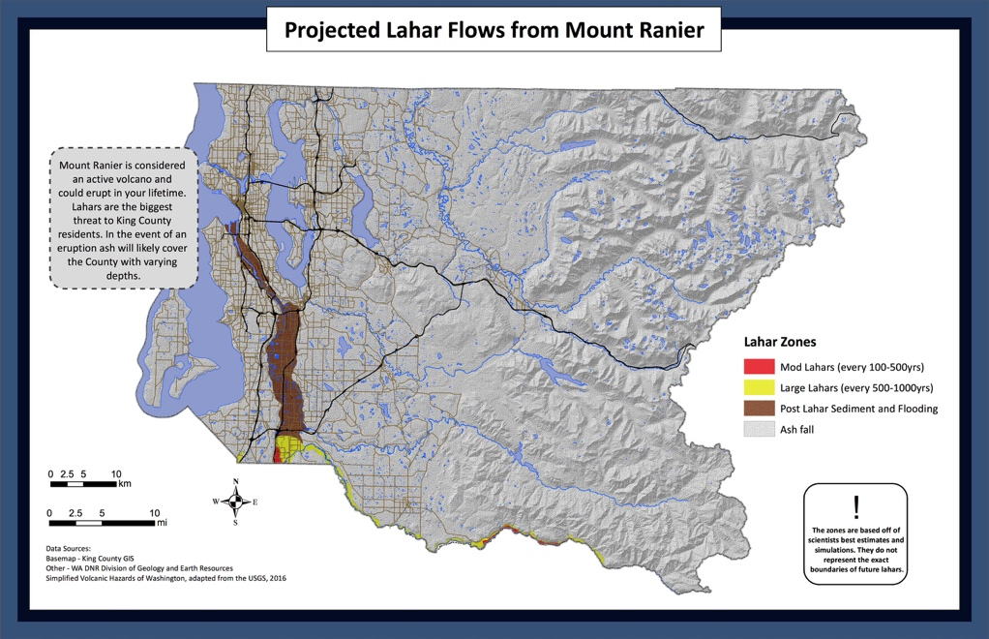

|  |  |
| --- | --- |
| Post-Lahar Sedimentation | Haddii foolkaanada ay kiciso Buurta Rainier, **aagaan wuxuu la kulmi karaa fatahaad iyo haraaga sida dhoobada, ciida, dhagaxaanta, iyo haraaga kale ee hoosta wabiga oo foolkaanada ah**. Tani waxay ka dhici kartaa sannooyin illaa labaataneeyo sanno foolkaanada kadib.[(qariirada)](https://hazardready.org/seattle/static/img/data/Volcano_Lahar.jpg) |
| Case II-Moderate Lahars (Recurrence Interval 100-500 yrs) | **A 10% - 40% fursad ka jirtay foolkaanada ee Buurta Rainier oo mareyso illaa gobolkaan oo 50-ka sanno ee xiggo.** Dabeecada foolkaanada oo u egtahay dhagax qoyan oo socdo. Dhoobo qaro adag iyo haraa ayaa daboolayo aaga haddii mid dhacdo. Tani waxay si xun u waxyeeleyn kartaa dhismaha oo waxay qaadan kartaa muddo dheer in looga soo kabsado. [(qariirada)](https://hazardready.org/seattle/static/img/data/Volcano_Lahar.jpg) |
| Case I-Large Lahars (Recurrence Interval 500-1000 yrs) | **A 5% - 10% fursad ka jirtay foolkaanada ee Buurta Rainier oo mareyso illaa aagaan oo 50-ka sanno ee xiggo.** Dabeecada foolkaanada oo u egtahay dhagax qoyan oo socdo. Dhoobo qaro adag iyo haraa ayaa daboolayo aaga haddii mid dhacdo. Tani waxay si xun u waxyeeleyn kartaa dhismaha oo waxay qaadan kartaa muddo dheer in looga soo kabsado. [(qariirada)](https://hazardready.org/seattle/static/img/data/Volcano_Lahar.jpg) |
| Outside of Lahar Zone&#44; but would see tephra and ash. | **Waxaad joogtaa AAGA KA BAXSAN HALISTA FOOLKAANADA**. Haddii Buurta Rainier qaraxdo dambas ayaa daboolayo gobolka. Waxay aad ugu ekaaneysaa sida aagaga saameysay qaraxa Buurta Saint Helen ee 1980. Qara weynida dambasta waxay ku kala duwanaaneysaa baaxada qaraxa. [(qariirada)](https://hazardready.org/seattle/static/img/data/Volcano_Lahar.jpg) |

## Aastaamaha Digniinta

|  |  |
| --- | --- |
| Warning signs | Foolkaanada caadi ahaan waxay siisaa siinyaalo digniin ah maalmo illaa billo ka hor inta aysan qarxin. **Howlaha gaaska iyo dhulgariirka wuu kordhaa iyo saqafka dhulka wuxuu u bararaa sida biyaha dhaxa ku qulqulayo hoosteeda.** Illaa aastaamahaan waxay noqon kartaa dhismo bulshada guud ah, Buurta Rainier waxaa si joogta ah u maamulay saynisyahanada leh [Barnaamijka Halisaha Foolkaanada USGS](http://volcanoes.usgs.gov/volcanoes/mount_rainier/). |

## U diyaargarow Foolkaanada

|  |  |
| --- | --- |
| Before | 1. **WEYDII** - Ogow tallaabooyinka saraakiisha deegaanka qaadeen oo ay ugu diyaar garoobeen dhacdooyinka foolkaanada. **Weydii saraakiisha bulshada waxa qorshahooda uu yahay iyo sida ay kugula soo xiriirayaan inta lagu jiro dhacdada**. Waxaad ku sameyn kartaa midaan adiga oo la xiriirayo Xafiiska Gobolka King [ee Maamulka Degdega](http://www.kingcounty.gov/depts/emergency-management/hazards/volcano.aspx). 2. **QORSHAHA** - La hadal saaxibadaada iyo dariska. Haddii aad joogtid aag halis sareyso, **go’aanso halka aad aadi laheyd, waxa aad keeni laheyd, iyo cida aad la xiriiri kartid**. |
| During | Inta lagu jiro qaraxa, dhageyso wararka aqbaaraha degdega iyo raac tilmaamaha gurmadka.   * **AAGA FOOLKAANADA - Hel dhul sareeyo isla markiiba.** * **BANAANKA** - Dabool afkaaga, sankaaga, iyo jirka si aad uga fogaatid xanaaqa. **Hel hoy**. * **GUDAHA - Xir albaabada iyo daloolada guriga oo gudaha ku jir, illaa lagaa tilmaamo haddii kale**. Saar shukumaanada xun mareenada albaabka iyo kuleey daaqadaha. Dami matoorada gaariga iyo taraagyada si aad uga fogaatid waxyeelada cariiriga dambasta. Ka illaali xayawaanada iyo mashiinada adiga oo keenayo gudaha ama aaga daboolan.   his is an panel of three images of what to do during a volcanic eruption or lahar. In lahar zone, outside, inside. |
| After | Kadib halista degdega ah ee qaraxa way yaraatay, nadiifinta dhacitaanada dambasta waxay noqoneysaa dhacdada ugu weyn.his image shows two graders shoveling inches of ashfall from Saint Helens' eruption   * Xiro ookiyaale iyo maaskaraha wajiga marka aad banaanka joogtid. **Tayada hawada way liidaneysaa**. * **Ka fogow daarnaashaha matoorka gaariga**. Haddii ay tahay inaad ka xeysid, ku haay xawaaraha hoos (oo ka yar 35 MPH) oo fiiri ooliyada, fiiltarada ooliyada, iyo fiiltarada hawada waa joogto * Dhacitaanada dambasta way culustahay oo waxay ku sababi kartaa dhismooyinka inay dumaan. Haddii ay badbaado tahay inaad sidaas sameysid, **ka cadey dambasta safaqyada iyo roob celiyayaasha**. |

|  |  |
| --- | --- |
| Volcano Resources | Waxaad wax badan ka baran kartaa ee ku saabsan Buurta Rainier iyo halisaha imaan karo illo badan:   * [Kormeerida iyo warbixinta kale](https://volcanoes.usgs.gov/volcanoes/mount_rainier/) - Sahanka Dhulka Mareykanka * [Warbixinta Guud ee Gobolka King](http://www.kingcounty.gov/depts/emergency-management/hazards/volcano.aspx) - Gobolka King * [Dhulka halista ah ee Rainier](https://www.nps.gov/mora/planyourvisit/geohazards.htm) - Adeega Darjiinka Qaranka * [Dhul gariirka u dhow Rainier](http://www.pnsn.org/volcanoes/mount-rainier) - Badda Wuqooyiga galbeed Shabakada Seismic |

## Taariiqda Hadeer

|  |  |
| --- | --- |
| Volcano History | Buurta Rainier waxay leedahay taariiq dheer oo [qaraxyo ah](https://volcanoes.usgs.gov/volcanoes/mount_rainier/geo_hist_eruption_history.html) iyo [foolkaano](https://volcanoes.usgs.gov/volcanoes/mount_rainier/geo_hist_lahars.html). Qiyaastii 500 sanno ka hor Qulqulka dhoobada Electron ayaa usu keenay buurta hoose ee ku safrayo dhinaca Puyallup iyo sida dheer ee Sumner, WA. Kumanaanka sanno ka hor inta aysan foolkaanadaas badan ku safrin dhinaca wabiyada gaarayo sida ugu dheer ee Auburn. **Magaalooyinka qaarkood (NE Tacoma, Orting, iyo Puyallup) waxay dhisantahay haraayada foolkaanada taariqiga ah.** |

# Cimilada Qaboobaha

## Waqtiga noloshaada: cimilada qaboobaha

|  |
| --- |
| Qaboobaha Gobolka King oo dhan wuxuu keeni karaa heerkululka qabow hooseeyo, wadooyin baraf ah, iyo duufaanaha weyn ee imaan kara. Dhacitaanka barafka wuxuu dhacaa mararka qaarkood, iyo aad u leedahay taagag sare. **Duufaanada qaboobaha waxay keeni karaan dabeyl sareyso ee ku sababo inay geedaha dhacaan oo korontada danto.** |

## Xaalada Ugu xun: Cimilada Qaboobaha

|  |
| --- |
| Dhacdada dhacitaanka baraf la taaban karo wuxuu ku sababi karaa carqalado gaadiidka, adeegyada badbaadada bulshada, iyo korontada. **Korontada waxay maqnaan kartaa maalmo badan.** |

## Saameynada Cimilada

|  |
| --- |
| **Badda Wuqooyiga galbeed waxay arkeysaa duufaan aad u daran oo 50-ka sanno ee xigo**. Waxay qaadi karaan dabeyl culus, dhacitaanka roobka mahiigaanka ah oo sababayo fatahaada. Howlaha qaboobaha way saameyneysaa. 2015 arag heerarka bacda barafka la qoray ee ugu hooseyso oo leh kaliya 4% oo isku celcelis. Qaboobaha diiran wuxuu dajinayaa heerka abaaraha gobolka oo dhan. Riix sawirka lagu ogaanayo wax badan.  [limate Change Winter Infographic](http://kingcounty.gov/services/environment/climate/why-act/infographic.aspx) |

## Aastaamaha Digniinta

|  |
| --- |
| Saadiyayaasha wuxuu sameeyay guul wanaagsan ee saadaalinta barafka iyo duufaanaha barafka. **Ka taxadar saadaalinta cimilada deegaanka oo iska diiwaangeli digniinta la heli karo iyo nidaamyada digniinta** ([Digniin sii Seattle](http://alert.seattle.gov/) iyo [Digniin sii Gobolka King](http://www.kingcounty.gov/depts/emergency-management/alert-king-county.aspx)) si aad u hubisid inaad heshid warbixinta ugu dambeyso ee ku saabsan cimilada daran ee hartay. |

## Diyaargarow

|  |  |
| --- | --- |
| Before | 1. **HEL SAADADKA - Keydso shidaal dheeraad ah iyo saadadka gurmadka** si aad ugu badbaadid dhoor maalmood iyada oo aan kroonto jirin, kuleelka, iyo biyaha kulul. Tixgeli inaad iibsatid ganareetar oo raac heerarka badbaadada. 2. **QABOOJI GURIGAAGA** - Geli daaqadaha duufaanta. Dahaarsaar darbiyada, dusha sare, iyo tuubooyinka. Saar biya celiyaha iyo goomaha cimilada albaabada iyo daaqadaha. U ogolow tubooyinka inay waxyar tifqaan inta lagu jiro cimilada qabowga si ay ugu joogteyso tubooyinka inay barafoobaan. **Baro sida loo damiyo faalfayaasha (haddii tuubo ay jabto)**. 3. **QABOOJI GAWAARIDAADA** - Ku hayso shidaalka si buuxdo ugu yaraan buux barkiisa. Hubi batariga, qalabka kicinta, hiitarka, nalalka, bareekyada, iyo taayarada. Ku buuxi biya daga ka hortaga barafka, ooliyada, iyo daaqadaha dhaqo biyaha. **Ku hay saadadka gurmadka qaboobaha buudkaaga.** |
| During | * **LA SOCO** - Ka kormeer aqbaaraha deegaanka talefeshinkaaga, qalabka mobeelka, ama raadiyaha batariga ku shaqeeyo. Raac tilmaamaha degdega oo ka taxadar inaad u safartid tallo bixin. * **KA FOGOW SAFARKA** - Haddii ay tahay inaad gaari kaxeysid, buuxi taangiga shidaalka, haay wadooyinka weyn, oo ogeysii dadka kale faahfaahintaada. Is tartiibi. Haddii aad xayirantid, u yeero caawin, daar nalalka halisaha, oo gaarigaaga joog. Banaanka cagahaaga haku fariisan illaa hoy uu kuu dhowyahay. * **OGOW HALISAHAAGA** -   + **Barafowga** - Haddii aad ogaatid aastaamaha hel caawinta caafimaadka isla markaasba. Wixii aastaamaha iyo warbixin kale riix [halkaan](https://www.cdc.gov/disasters/winter/staysafe/hypothermia.html).   + **Sumowga Gubashada Gaaska** - Waxay dhacdaa markii shidaalka sida gaaska, ooliyada, bansiinka, alwaaxa, ama dhuxusha ay ku gubato boos xiran. Boqolaal dad ayaa sannad walba si shil ah ugu dhinto. Ka ogow wax badan [halkaan](http://www.kingcounty.gov/depts/health/emergency-preparedness/preparing-yourself/carbon-monoxide.aspx). * **KA FOGOW HALISAHA** - Si cad uga tala bixi leemanka korontada soo dhacay, fatahaada, wadooyinka, iyo qaabdhismeedyada kale ee dumiyay barafka culus am barafka.   his is a panel of four images of what to do during bad winter weather. Stay Tuned, Stay Inside, Know Risks, and Avoid Hazards. |
| After | * **Dib u iibso saadadka gurmadka**. U diyaargarow haddii duufaan kale ku dhafato. * **Hormari qorshaha qoyskaaga** - Maxaa shaqeeyay? Maxaa la wanaajin karaa? * **La hadal dariskaaga**. La wadaag tallooyinka iyo afkaaraha midba midka kale. |

## Illaha Deegaanka

|  |
| --- |
| Baro wax badan oo ku saabsan xaalada qaboobaha iyo sida loo diyaar garoobo:   * [Ku qaado Qaboobaha Duufaan ahaan](http://takewinterbystorm.org)- Tallooyinka diyaargarowga iyo warbixinta la cusbooneysiiyay ee Galbeedka Washington * [Gobolka King Qaboobaha Metro](http://kingcounty.gov/depts/transportation/metro/alerts-updates/winter.aspx) - Qadadka app-ka qorsheynta safarada qaboobaha iyo digniinta cimilada * [Waaxda Gaadiidka ee Seattle](https://www.seattle.gov/transportation/winterweather.htm) Fiiri halka baraf ka dhacay iyo warbixinta kale ee xaaladaha wadada |

## Taariiqda Hadeer

|  |
| --- |
| **Taxanaha barafka, barafka iyo roobka duufaanta ee bilowga Diseembar 26, 1996, wuxuu sababay 16 dhimasho oo gobolka ah iyo $57 milyan oo waxyeelo ah ee Gobolka Seattle iyo King**. Labo duufaano — hal gubasho 6-12 inji iyo 10 inji ee barafka qoyan — halka ay raacaan roobka culus kaas oo dumay kanbiga, meesha doomanka daboolan, iyo leemanka korontada oo wareegto ah. Adeega la hakiyay ee ku meelgaark aah ee Metro gabi ahanba waqtigii ugu horeysay ee taariiqdeeda. Qabowga iyo dhallaalka barafka waxay ku deeqaan fatahaad iyo dhulalka buurta ah inta lagu jiro isbuuca xiggo. Diyaar ma u tahay haddii duufaan saan oo kale ah ay dhacdo markale? |

# Cimilada Kuleelaha

## Oo noloshaada ah: Cimilada Kuleelaha

|  |
| --- |
| Ha u ogolaan dhacitaanka roobka iyo qaboobaha inay ku harowdasaan, **kuleelaha Gobolka King wuxuu noqon karaa KULEEL. Mararka qaarkood heer kululka wuxuu u kacaa illaa heerka 90s oo maalmo badan ah waqtigiiba**. Duufaanta hilaaca, duufaanta dabeysha, dabka duurka, iyo hirarka kuleelka waa suurtogal gobolka oo dhan. |

## Xaalada Ugu xun: Cimilada Kuleelaha

|  |
| --- |
| Kuleel daran ayaa socon karo maalmo oo ku sababayo bulshooyinka inay arkaan korodhka kuleelka la xiriiro jirada oo ay ku jiraan DAALKA KULEELKA iyo ISTAROOGA KULEELKA. Heerkululka biriqda, xaaladaha qaleelka, iyo korodhka suurtaglnimada biriqda ee dabka duurka. |

## Saameynada Cimilada

|  |
| --- |
| Luuliyo 2015 waxay aheyd bisha ugu kulul ee soo marta! **Isku celceliska heerkululka sannadlaha waxaa lagu saadilay inay kordheyso inta u dhaxeyso heerka 3 iyo 10 ee Heerkululka xiliga 2100**. Dadka dagan Washington waxay arkayaan dhacitaanka roobka kuleelaha, laakin dhacitaanka roobka ee aan ka dhicin wuu cuslaanayaa (ku fakar roob culus). Riix sawirka lagu ogaanayo wax badan.  [limate Change Storm Infographic](http://kingcounty.gov/services/environment/climate/why-act/infographic.aspx) |

## Aastaamaha Digniinta

|  |
| --- |
| Daalka kuleelka iyo istarooga kuleelka waa jiro daran ee dhici karta markii qofka gaaro kuleel daran.  **AASTAAMAHA DAALKA KULEELKA**:   * Dhidid badan * Tabar daro * Garaaca wadnaha oo liito * Suuxdin * Matag * Qabow, maqaarka cadaado   **AASTAAMAHA ISTAROOGA KULEELKA**:   * Heerkululka jirka sareeyo (103F ama ka sareeyo) * Maqaar kuleel oo qalalan * Garaaca wadnaha degdega oo xoogan * Miiyir beel suurtogal ah |

## Diyaargarow

|  |  |
| --- | --- |
| Before | Dadka weyn, carruurta yar, iyo dadka qaba jirada maskaxda iyo cudurada raaga way ku badanyihiin halisaha arimaha kuleelka la xiriiro.   1. **OGOW AASTAAMAHA** - Jirada kuleelka la xiriiro dhaqso ayay dhici kartaa. Ogow iyo midkee ka mid ah dariskaaga ayaa halis ku jiri karo. 2. **KA WARHAY** - Dhageyso aqbaaraha deagaanka oo warbixinta guud ah iyo goobaha ee **xarumaha qaboojinta** (boosaska bulshada ee ay u isticmali karaan dadka dagan inay isku qaboojiyaan) |
| During | * **QABOOBANOW** - Gudaha joog iyo, haddii ay suurtogal tahay, meesha qaboojiyaha (moolalka adeega, maktabadaha, masraxyada, iwm). Xadey howsha banaanka. * **ILLAALI MAQAARKAAGA** - Xiro dhar qafiif ah, midib qafiif ah leh, oo dabacsan. Koofiyad ku dbaoosha oo balaaran, ookiyaale, iyo kareemka quraxda way ku caawineysaa. * **CAB BIYO**: Cab biyo badan (ka fogow kafeega, qamriga, iyo cabitaanada sonkorta leh) oo qaado dhalo biyo ah. * **KA FAKAR DADKA KALE** - Ka fogey carruurta iyo xaywaanada guriga baabuurta kulul. Fiiri qoyska halista ku jiro, saaxibada, iyo dariska inta badan.   his is a panel of three images of what to do during bad summer weather. Stay Cool, Protect Skin, and Drink Water. |
| After | * Isticmaal daahyada daaqada **si aad ugu dabooshid daaqadaha si aad ugu hawada qabow ugu haysid gudaha**. * **Tixgeli iibsashada qalabka qaboojiyaha** iyo/ama gelinta goomaha cimilada guriga halka hawada kulul ay ka soo gasho. * **DOOQA MIISAANIYADA HOOSE**: Dhiso muujiyayaasha kuleelka (oo isticmaalka u dhaxeeyo daaqadaha iyo goomaha daaqadaha), sida jaandiga kartoonada la daboolay, si loogu daboolo kartoomada bireed si ay ugu celiso kuleelka banaanka. Riix [halkaan](http://www.instructables.com/id/Heat-blocking-curtains/) oo DIY tilmaaha. |

## Illaha Deegaanka

|  |
| --- |
| Wixii warbixin dheeraad ah ee sida qabow loo ahaado iyo badbaadada madaxa [Cimilada Kuleelka](http://www.kingcounty.gov/depts/health/emergency-preparedness/preparing-yourself/hot-weather.aspx) ee Gobolka King bogga. |

## Taariiqda Hadeer

|  |
| --- |
| 2015, Gobolka King wuxuu diiwaaniyay tirada maalmaha ay dhaaftay 90F. **Luuliyo 2015 waxay aheyd bisha ugu kulul ee marnaba lagu qoray Gobolka King!** |

# Warbixinta Tirikoobka ee Bogga

## Qalabka Qeybinta

|  |
| --- |
| Qubarayaasha waxay soo jeedinayaan sida xigto:   * 7 Maalmood ee saadadka qofkiiba * 7 Galoon oo biyo ah qofkiiba * 21 Cuntooyin qofkiiba   Waxay u dhowdahay inaad haysatid sheeyada ugu badan ee aad ugu baahantahay [sanduuqa saadka qoyska](http://www.seattle.gov/emergency-management/be-prepared-infographic_oem) diyaar ah. Ogow waxa kale ee lagu darayo oo la diyaarinayo ka hor inta aysan ku dhufan dhacdada labaad. |

## Qadadka Muhiimka ah

|  |
| --- |
| **Xafiiska Maamulka Gurmadka Seattle**  Websaydka [Seattle OEM](http://www.seattle.gov/emergency-management) wuxuu leeyahay illo wanaagsan oo aad u badan oo ogaanshaha wax badan.  **Digniin sii Seattle**  Noqo qofka ugu horeeyo ee ogaado waxa aktaada ka dhacayo. Ka ogow wax badan [halkaan](http://alert.seattle.gov/).  **Digniin sii Gobolka King**  Hel digniinada waqtiga dhabta ah waxa ka dhacayo Gobolka King. Ka ogow wax badan [halkaan](http://www.kingcounty.gov/depts/emergency-management/alert-king-county.aspx). |